Acceptable Use of Social Media Letter to Parents

Vine Tree Primary School
Dane Bank Avenue
Crewe
Cheshire East
CW2 8AD
27th January 2023
RE: Parents’ use of social media

Dear parents,
Vine Tree Primary understands and appreciates the benefits of social media; however, there may also be some significant negative impacts, such as cyber bullying, which the school does not tolerate.
For us to set the best example possible to pupils at the school, we would like to invite parents to also lead by example. The school urges parents to review and sign our code of conduct, which outlines how to act when using social media.
Should the school be subject to any online abuse, we will take the appropriate action, which may include considering our legal options to deal with any defamatory or libellous activity on social media.
If any parents do have any concerns to raise, or would like to discuss this subject further, please contact myself directly on 01270 661526.
Kind regards,
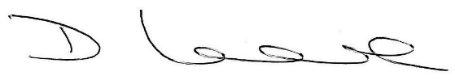

Mr Darren Locke
Headteacher

Parental Declaration Form

I __________________________ (name), parent of ____________________ (name of child), declare that I have received, read and understood the terms and conditions of this code of conduct.
I understand my obligations under this code of conduct and agree to comply fully with them. I will ensure that my conduct does not breach this code of conduct in any way, including:
- Sending abusive messages to parents or teachers.
- Sending abusive messages about parents and teachers.
- Posting defamatory ‘statuses’ about other parents, pupils, teachers or the school.
- Using social media to complain or post any grievances about the school’s values and methods.
- Posting statuses containing confidential information, e.g. regarding a complaint outcome.
- Contacting school employees through social media, including requesting to ‘follow’ them or sending them private messages.
- Creating or joining private groups or chats that victimise or harass a member of staff or the school in general.

Signed: ________________________________

Date: __________________________________

