Our reading journey in Reception
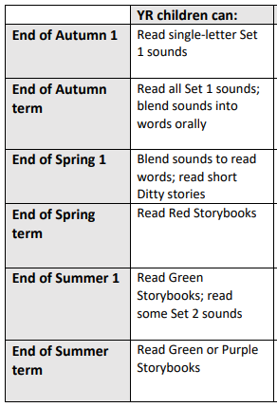
This table show you where we ideally want all children to be at the end of each half term.

The sounds made by the 26
letters of the alphabet.

These include: sh, th, ch. qu,
ng, nk, ck. Orally blend means
children hear r-e-d and r-e-d
red.

Children can now see red and
read r-e-d, red.

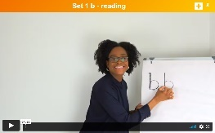
How you can help support your child at home:
- Watch the Virtual Classroom with your child

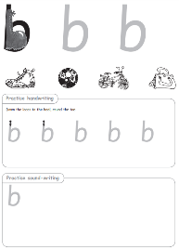
- Support your child with their sound homework sheets

- Incorporate Fred talk or Fred Games daily
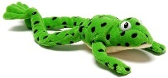

- Play sound games

- Use pure sounds (no -uh at the end of sounds)
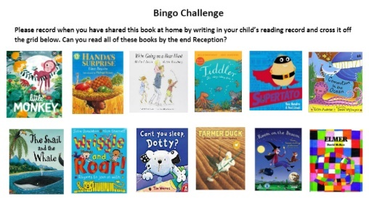
- Read high quality books to your child

