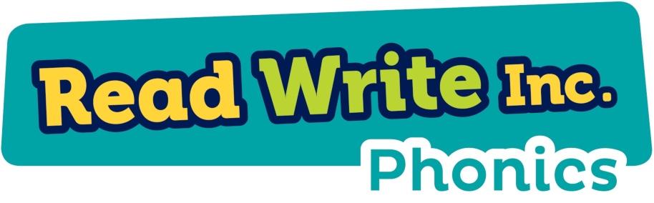

Set 1 sounds
This is the order that you child will be taught the sounds:
m a s d t i n p g o c k u b f e l h r j v y w z x

Followed by:
sh th ch qu ng nk ck

Red words
These are words that you can not sound out/Fred talk.
Here is a list of the red words your child will encounter in their reading whilst in Reception:

the | I | no
of | my | he
your | said | you
be | are | to
me | go | she

