Sound Games
Create sound cards drawing the rhyme images on one side. Flick through the pack with your child telling you each sound. Using the picture side may help them to recall the sound if they are unsure. You could also get them to repeat the sound after you say it. | Hide the cards you’ve made behind your back and then flash them to your child in a random order. Can they recall each sound? | Hide the sounds around the house and get your child to go on a sound hunt. Can they tell you each sound as they find them?  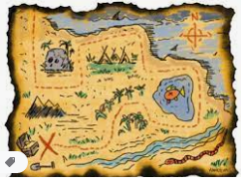
Write the sounds on post-it notes/scraps of paper and stick them in key places around the house. Get children to say the sounds, daily, as they walk past them.  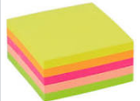 | Write the sounds onto scrap paper and scrunch them up like snowballs. Have a snowball fight before getting your child to read all the snowballs that hit them! | Say the sound and see if your child can write it down. You could use a range of colouring crayons or paints when writing.
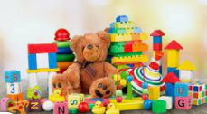  Get your child to pick 6 toys and give each toy a sound. Then ask your child to pick a sound card from the pack. If they can read the sound then they win the toy with the matching sound! | 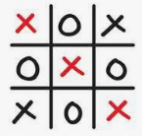  Write the sounds into a naughts and crosses grid. You can only do your naught or cross after reading the sound. | 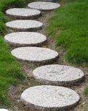  Write the sounds onto scrap paper and spread them across the floor. Can your child jump to each sound and correctly read it?

You are more than welcome to send photos/videos of your child enjoying these activities to the class email (reception@vinetree.org.uk) for us to celebrate in school.

Take a look at the following websites for more fun and inspirational games:
- Five minute mum: https://fiveminutemum.com/

- Phonics family: https://phonicsfamilycom.wordpress.com/

Sound Games
Create sound cards drawing the rhyme images on one side. Flick through the pack with your child telling you each sound. Using the picture side may help them to recall the sound if they are unsure. You could also get them to repeat the sound after you say it. | Hide the cards you’ve made behind your back and then flash them to your child in a random order. Can they recall each sound? | Hide the sounds around the house and get your child to go on a sound hunt. Can they tell you each sound as they find them?
Write the sounds on post-it notes/scraps of paper and stick them in key places around the house. Get children to say the sounds, daily, as they walk past them. | Write the sounds onto scrap paper and scrunch them up like snowballs. Have a snowball fight before getting your child to read all the snowballs that hit them! | Say the sound and see if your child can write it down. You could use a range of colouring crayons or paints when writing.
Get your child to pick 6 toys and give each toy a sound. Then ask your child to pick a sound card from the pack. If they can read the sound then they win the toy with the matching sound! | Write the sounds into a naughts and crosses grid. You can only do your naught or cross after reading the sound. | Write the sounds onto scrap paper and spread them across the floor. Can your child jump to each sound and correctly read it?

You are more than welcome to send photos/videos of your child enjoying these activities to the class email (reception@vinetree.org.uk) for us to celebrate in school.

Take a look at the following websites for more fun and inspirational games:
- Five minute mum: https://fiveminutemum.com/

- Phonics family: https://phonicsfamilycom.wordpress.com/

