Parents’ Focus Group Meeting Minutes 19th May 2023
- Introductions

- Group Intent Statement

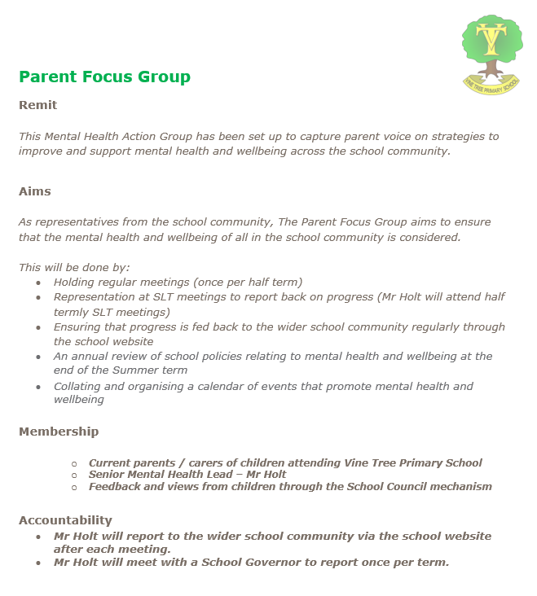

- Scaling Activity – What is your experience of mental health in the school as a parent?
We used the Bounce Together School Wellbeing Survey to scale our experience of mental health and wellbeing at Vine Tree. Scale of 1 to 5.
How much would you say your child enjoys being at our school? What is stopping it from being the highest number?
Responses between 3 and 5. Children do not like certain subjects. The group feel that there is a lack of play in learning. Some children have anxiety around the behaviour of certain children in their class.
Questions 2 – 5 related to knowing who to turn to if children have problems, parents knowing who to go to and key adults who have responsibility.
The group felt that their children knew who they could talk to if they wanted to talk and had multiple options of adults in and outside of school that they could talk to.
Do you feel that you have the opportunity to express your view of your child’s feelings towards school and their own wellbeing?
The group felt that prior to this meeting that there was no mechanism for parents to express their views. There is a feeling of not being listened to and a lack of cohesion in the school community between staff and parents.
The group suggested a parent survey to engage parents and seek their views on key issues.

Questions 6 and 7 were related to support available for mental health and wellbeing in school.
The group feels that there is a lack of proactive mental health learning.
The group raised concerns that the Emotional Literacy Support Assistant (ELSA) is being used for covering lessons too often, which is causing a lack of consistency in support to those who go to see her.
The group feel that the behaviour of other children affects wellbeing.
The group feel that mental health and wellbeing are not actively promoted or communicated with parents or the wider community.

Question 8 onwards sparked a discussion in the group around the priority of mental health and wellbeing in conjunction with physical activities and activities before / after school.
The group feel that there is a lack of after school clubs (sports etc.), which affects physical and emotional wellbeing. Parent involvement in setting up and running clubs is not being used.
The group feel that sports events are not celebrated as much as they could be – pictures of events are not always shared and assemblies do not highlight sports achievements.
The group raised the issue of a lack of after school activities, such as ‘read and chill’, ‘cookery’ etc. that are offered at other local schools. The group raised the concern that this could lead parents to choosing to send their children to other local schools in the future.
The group raised the concern that organised events, such as summer fair / bonfire night celebrations have stopped as a result of the pandemic and never returned, which is damaging social cohesion for the school community.
The group highlighted that there is no functioning PTA at present, which is missing the opportunity to get enthusiastic parents involved in the life of the school.
The group raised concern that residential trips seem to have stopped and that trips seem to have been reduced or replaced by visitors to the school. The group suggested that parents be consulted in a parent survey to ask about trips for the coming year.

- School Development Actions

As a result of this discussion, the group decided that the first priority is to seek to set up a Parent-Teacher Association with the aim to arrange more after school activities and opportunities for the whole community to come together (Summer fair / Bonfire night etc.)

- Time and Date for the Next Meeting
Friday 14th July

