Vine Tree Primary School
English overview Year 5 2022-2023
Term  curriculum link | 2 weeks Fiction | 2 weeks non-fiction | 1-2 weeks poetry | No Outsiders
Autumn 1  Curriculum driver: geography - Can I become a cartographer?  D&T – bridges | Title: Theseus and the Minotaur  Author: myths.e2bn.org  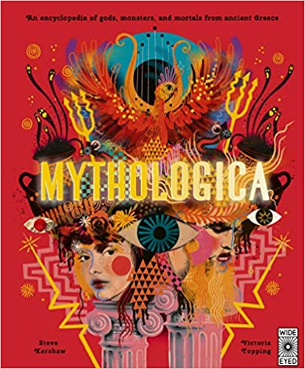  Title: Mythologica  Author: Dr Stephen P Kerhaw  Content domain: 2a vocabulary | Title: mountians of the the world  Author: Dieter Braun  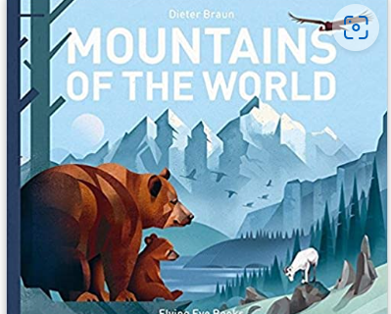  Title: Mountains – a dazzling journey  Author:Rebecca Kahn  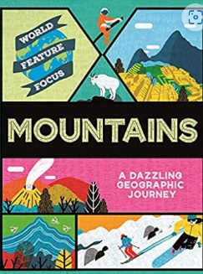  Title: World of Wonder: mountains  Author: Charlotte Guillain  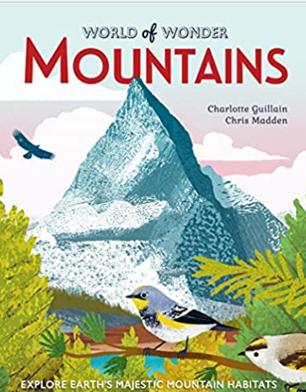  Title: How do bridges work  Author:Roman Belyaev  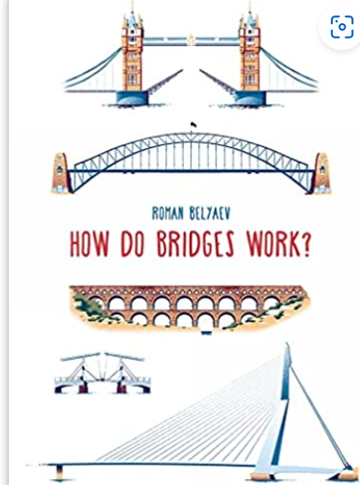  title: Myth atlas  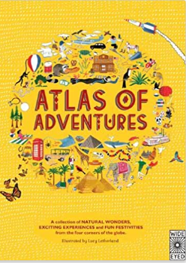  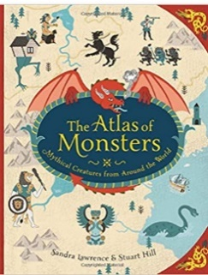  Author: Sandra Lawrence  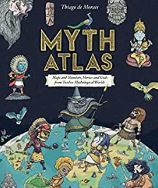  Title: atlas of adventures  Author:Lucy Letherland  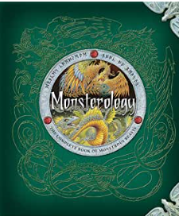  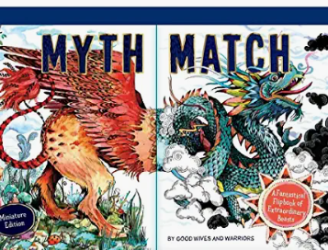  Title: the picture atlas  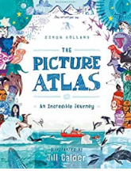  Author: Simon Holland  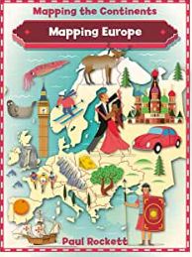  Title: mapping europe  Author: Paul Rocket  Content domain: 2c summarising | Title: Maze  Poet: Gina Douthwaite (shape poem)  Title: The Raven  Poet: Edgar Allan Poe  Title: Falling out of the Sky (Minotaur poem)  Poet: Emma Wright  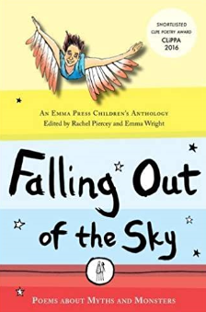  Content domain: 2d inferring | Title: And Tango Makes Three  Author: Justin Richardson  and Peter Parnell  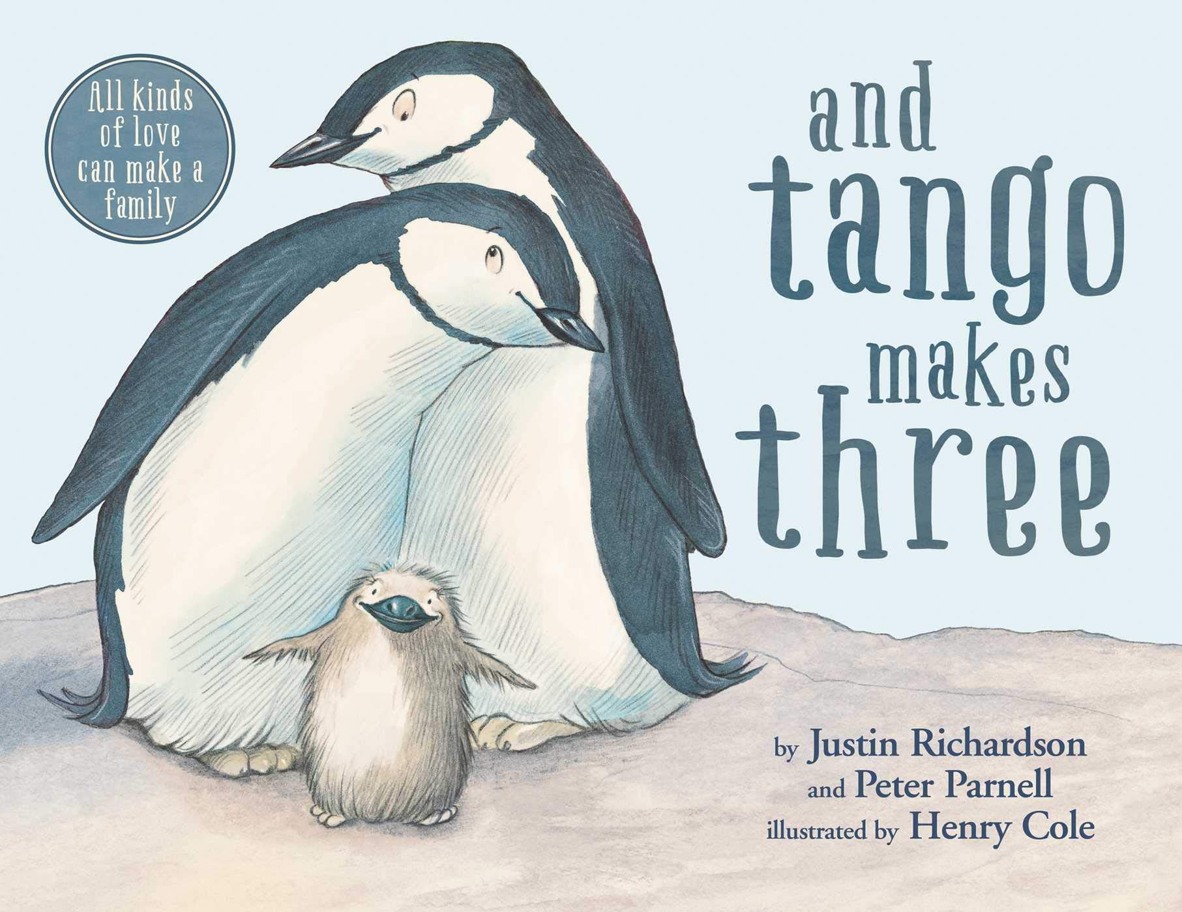  Title: Worm loves worm  Author: J J Austrian  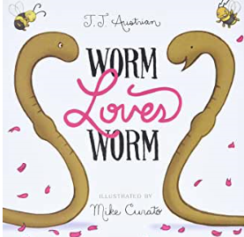  What makes up a person’s  identity?
Autumn 2  Curriculum driver: history  Why do people go on journeys? | Title:Henry’s Freedom Box  Author: Ellen Levine  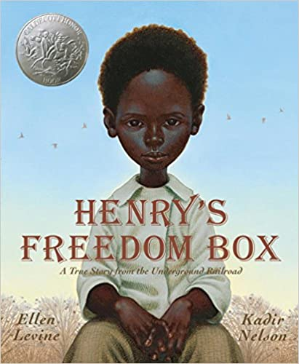  Title: wind rush child  Author: Benjamin Zephaniah  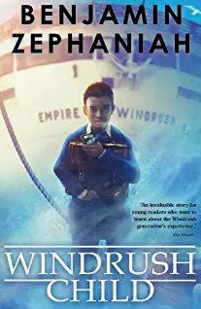  Title: Fly me home  Author: Polly Ho-Yen  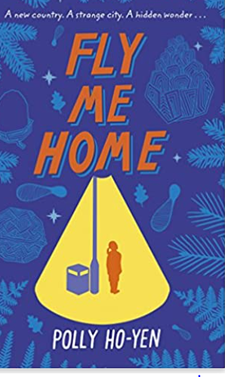  Title: Jemmy Button  Author: Valerio Vidali  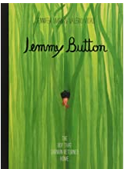  Content domain: 2e predicting/2e inference | Title: The plce for me: stories about the windrush  Author: Dame Floella Benjamin  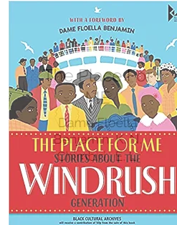  Title: Black and British  (Windrush to today chapter)  Author:David Olusoga  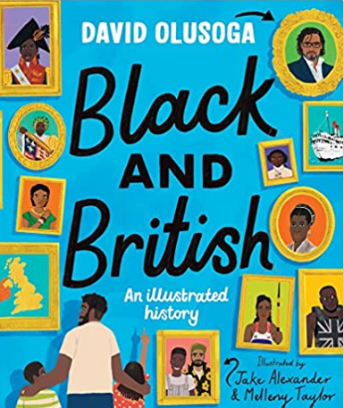  Title: Althea Mcnish: a cultural icon  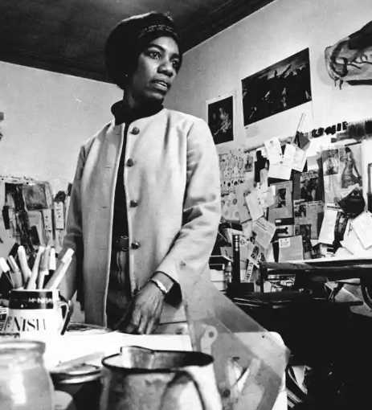  Title: Vera Shaufeld – a life story  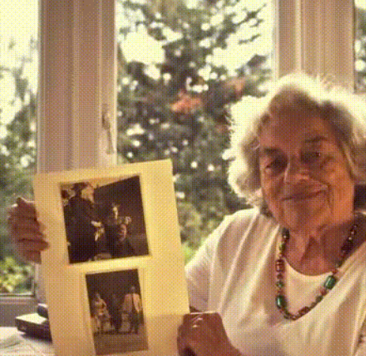  Content domain: 2b retrieval | Title: the British  Poet: Benjamin Zephianiah  Title: Caged Bird  Author: Maya Angelou  Title: still I rise  Author: Maya Angelou  Everyone Comes From Somewhere | Centre for Literacy in Primary Education (clpe.org.uk)  Title: windrush child  Poet: John Agard  Windrush child | Centre for Literacy in Primary Education (clpe.org.uk)  Content domain: 2f explaining language/visualiation | 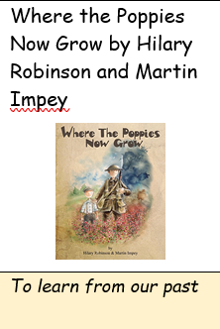
Spring 1  Curriculum link: LIFE CYCLES | Title: Manfish: a story of Jacques Cousteau  Author: Jennifer Berne  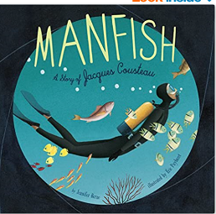  Content domain: 2d – inferring | Title: Life Cycles: Everything from start to finish  Author: DK  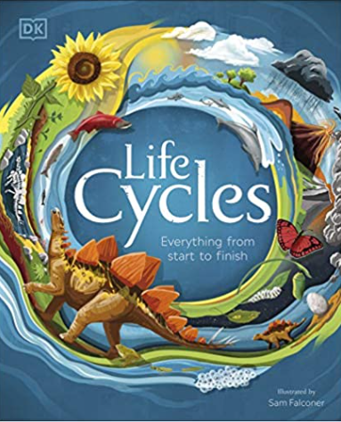  Title: Ocean: a visual encyclopaedia  Author: DK  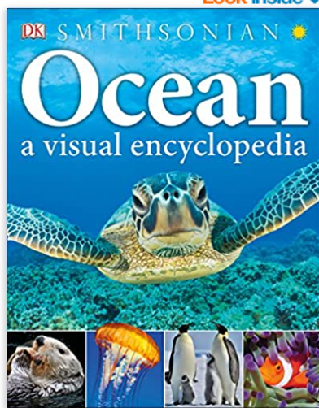  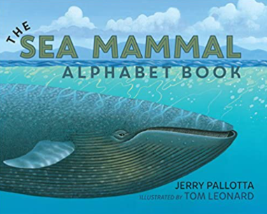  Content domain: 2a vocabulary | Title: dreams  Poet: Langston Hughes  Title: dream keeper  Poet Langston Hughes  Title: A Dream Deferred  Poet: Langston Hughes  Title: Fog  Poet: Carl Sandburg  Title: Silver  Poet: Walter de la Mere  Title: last night I saw the city breathing  Poet: Andrew Fusek-Peters  Content domain: 2a vocabulary | Title: How to heal a broken win  wing  Author: Bob Graham  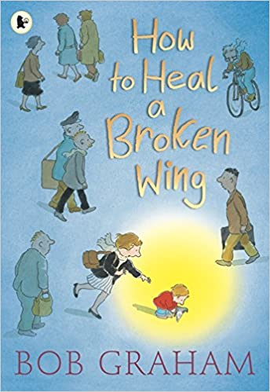  Theme: recognising when  Someone needs help
Spring 2  Curriculum driver: history – Would I want to have been an Anglo- Saxon? | Title: Clockwork  Author: Philip Pullman  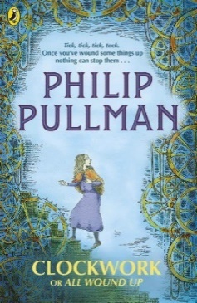  Title: The Viewer  Author: Gary Crew  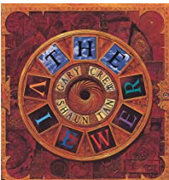  Or  Title: Beowolf  Author: Michael Morpurgo  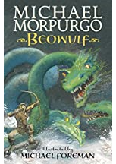  Content domain: 2b retrieval | Title: How to be an Anglo-Saxon in 13 easy steps  Author: Scouler Anderson  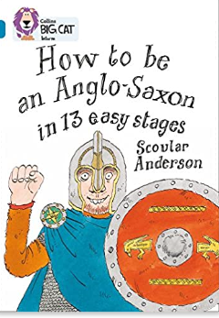  Title: You wouldn’t want to be an Anglo-Saxon peasant  Author: Jacqueline Morley  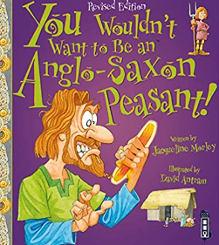  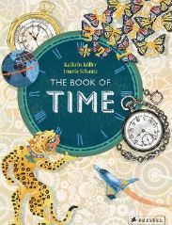  Content domain: 2b retrieval | Title: clockwise  Author: John Agard  Title: Time  Poet: Valerie Bloom  Title: Earth’s clock  Poet: Pat Moon (the works 2 p208)  Title: talking time  Poet: james carter  Title: If lonesome were a pot of gold  Author: Dennis Lee  Content domain: 2g authorial intent | 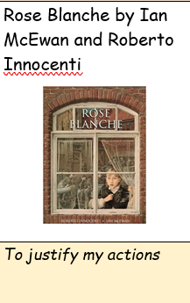
Summer 1  Curriculum link: science -  Is there anybody out there? | Title: The War of the Worlds  Author: H G Wells  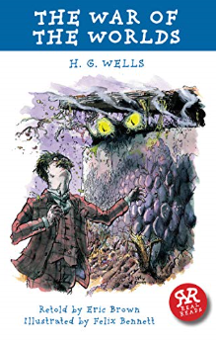  Title: George’s Secret Key to the Universe  Author: Lucy & Stephen Hawking  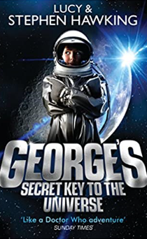  Content domain: 2h compare/analyse | Title: How to be a Space Explorer  Author: Lonely Planet  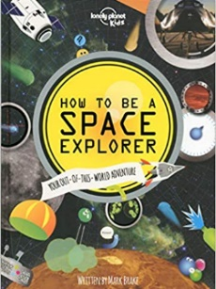  Title: Dr Maggies Grand tour of the Solar System  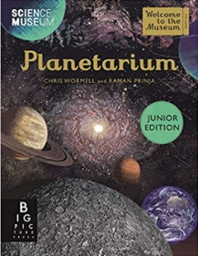  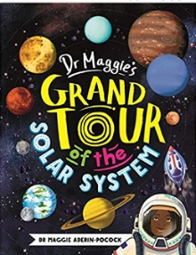  Author: Dr Maggie Aderin-Pocock  Content domain: 2g authorial intent  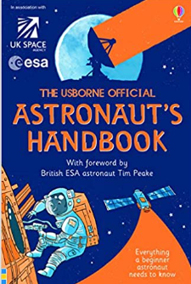 | Title: evening shifts  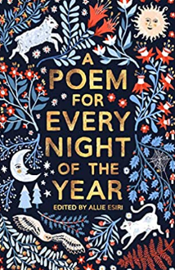  Title: how many moons  Poet: Graham Denton  Title: The Moon Speaks  Poet: James Carter  Title: the moon was but a chin of gold  Poet: Emily Dickinson  Title: Cosmic disco  Poet: Grace Nichols  Content domain: 2d infer  title: the wind and the moon  poet: George Macdonald | Title: A Galaxy of Her Own:  Amazing Stories of Women  in Space  Author: Libby Jackson  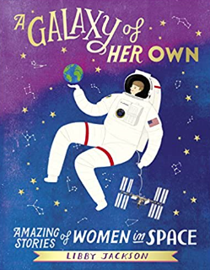
Summer 2  Curriculum driver: geography -what makes the rainforest so special?  Curriculum driver: science – What came first – the chicken or the egg? | Title: The Explorer  Author: Katherine Rundell  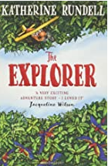  Content domain:2b retrieval  Title: Wild World  Author: Angela Mcallister  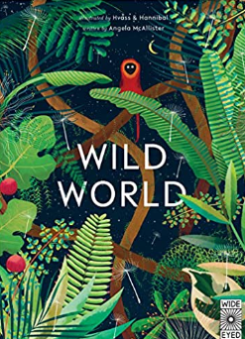 | Title: Animalium  Author: Jenny Broom  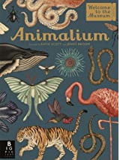  Title: Rainforests in 60 seconds  Author: Jen Green  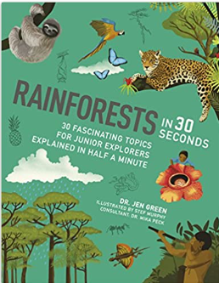  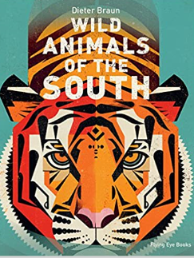  content domain: 2a vocabulary  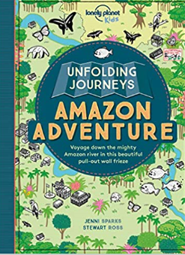 | Title: All the Wild Wonders  Poet: Wendy Cooling  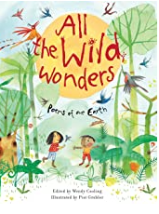  Title: web of life  Poet: wild and wonderful poems about the natural world  Title: The Amazon  Poet: Jane Goulbourne  Title: A poison Tree  Poet: William Blake  Title: a tree felled  Poet: Valerie Bloom  Content domain: 2d infer | 