Vine Tree Primary School Year Six
Whole class reading overview
E Woodward 2022-2023
Term  curriculum link | 2/3 weeks Fiction | 2 weeks non-fiction | 1/2 weeks poetry | PSHE
Autumn 1  driver: history ?  What part did Britain have to play in WW2? | 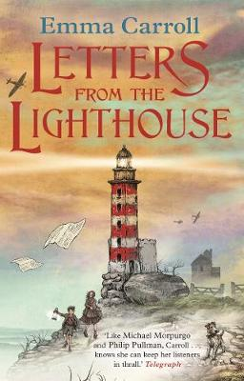  Title: Letters From The Lighthouse  Author: Emma Carroll.  Content domain: 2e Predicting/2d inferring | 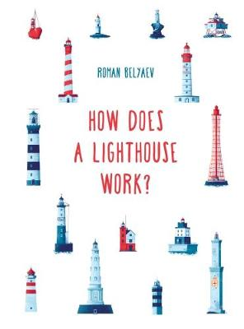  Title: How Does A Lighthouse Work?  Author: Roman Balvaez.  Content domain: 2b retrieval | Title: the blackout  : 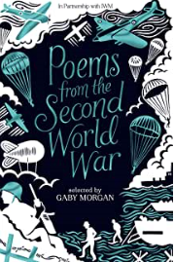 | Title: The Island  Author: Armin Greder  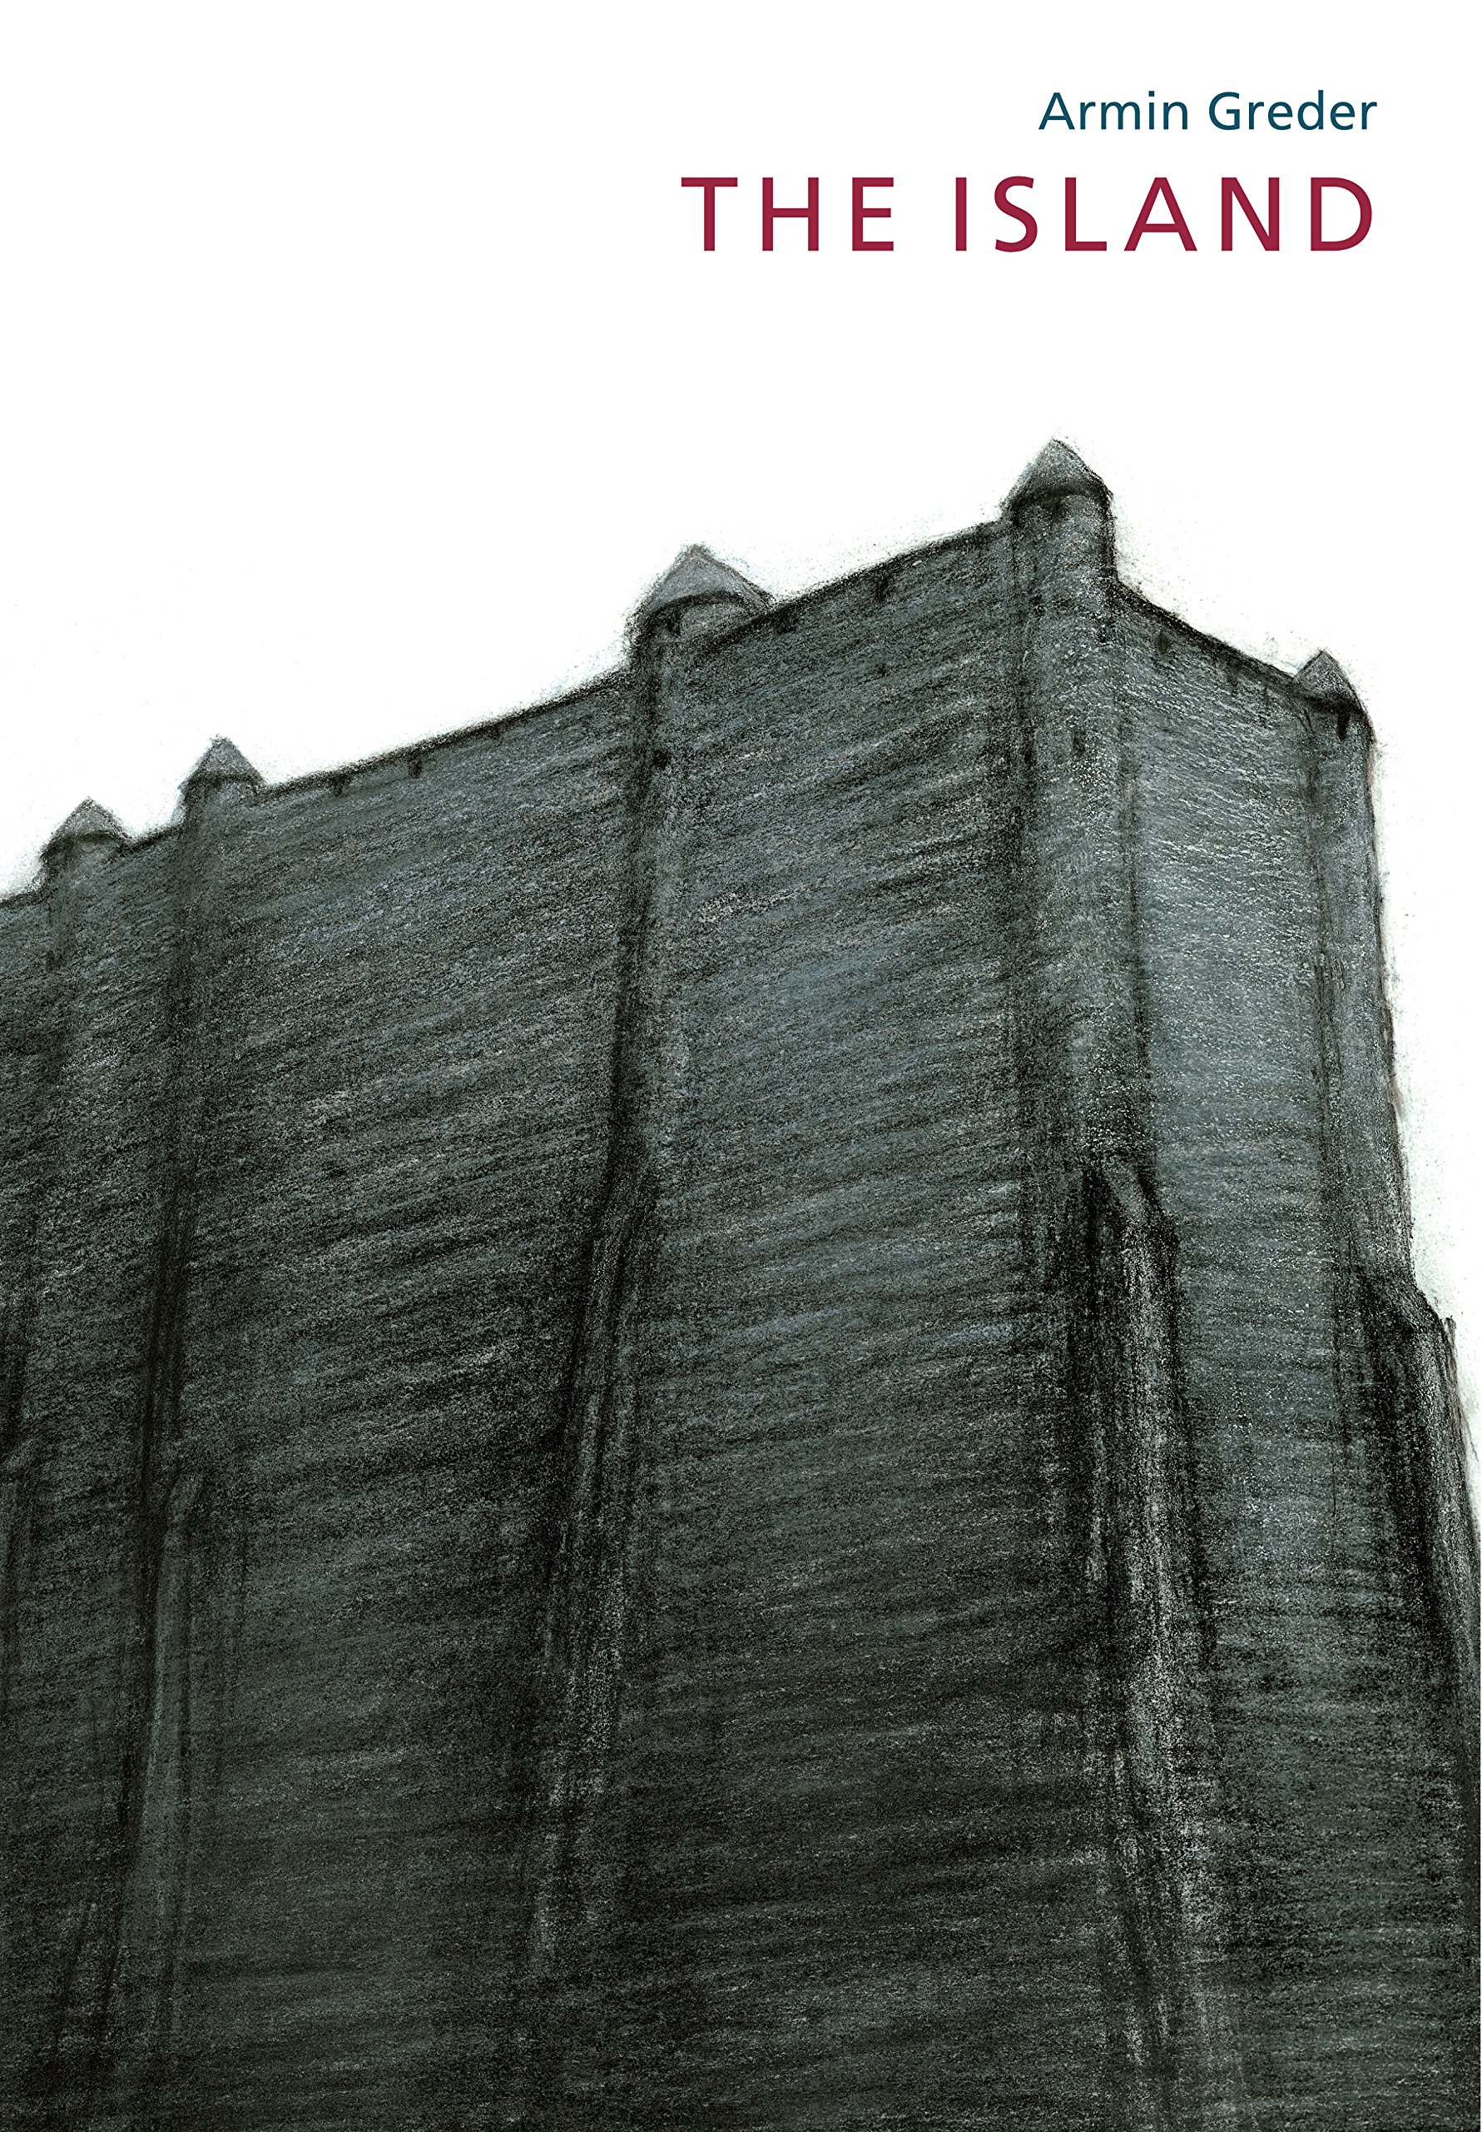  To challenge the causes of racism
 | Title: Erika’s Story  Author: Ruth Vander Zee  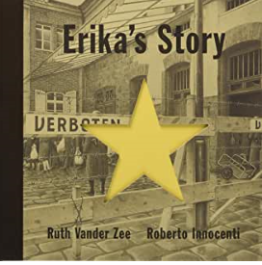  Content domain: 2e Predicting/2c summarising | Title: World War Two  Author: DK Eyewitness  Or TES news report  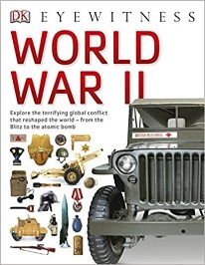  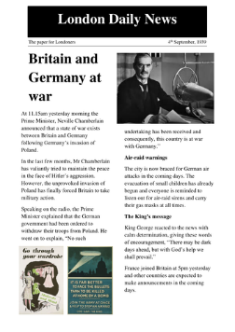  Content domain: 2c Summarising | Title: In Flanders Fields  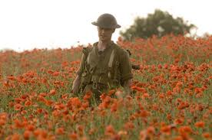  Author: John Content domain: 2d – Inferring/analyse and infer
 | Title: The Harmonica  Author: Tony Johnston  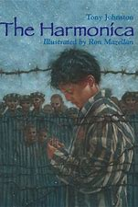 | Title: the Diary of Anne Frank  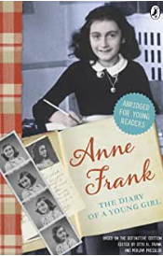 | Title: Empty your pockets  Poet:John Pudney  Title: the shape of Anne Frank’s Soul  Poet: Louise Greig  (a poem for every night of the year p34) | Title: Farther  Author: Grahame Baker-Smith  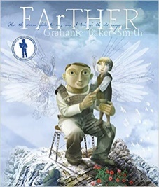
Autumn 2  Curriculum link: Have we always looked like this?  Science: Evolution and inheritance.  Author focus: David Almond | Title: Skellig  Author: David Almond  Content domain: 2a Vocabulary/2d inference  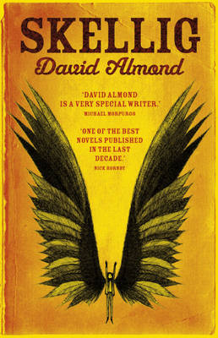  Title: The woman who turned children into birds  Author: David Almond  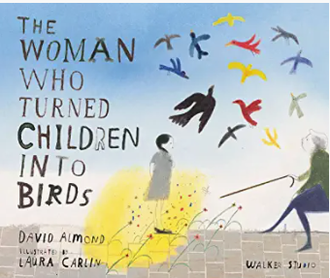  Title: my Dad’s a birdman  Author: David Almond  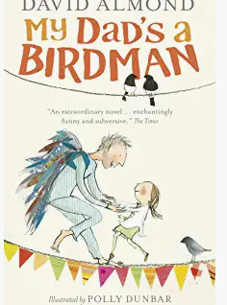  Title: The Dam  Author: Da vid Almond  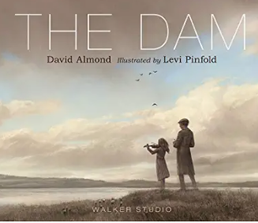  Title: the Savage  Author: David Almond  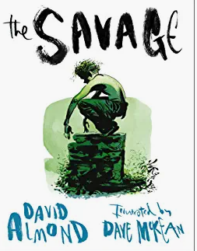  Title: the boy who swam with piranhas  Author: David Almond  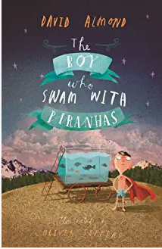  Title: Darwin’s Dragons  Author: Lindsay Galvin  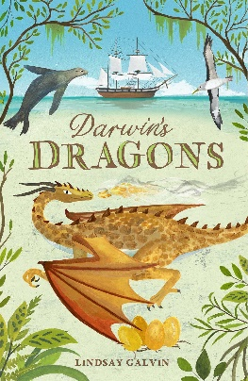 | 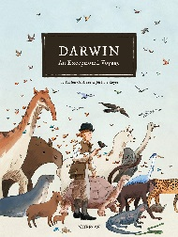  Title: Darwin-an exceptional voyage  Author: Fabien Grolleau / Jeremie Royer  Content domain:  2h Comparisons within text  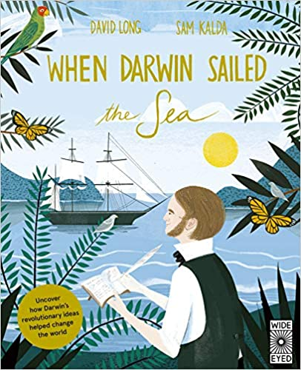  2b Retrieval  Title: when Darwin sailed  Author: David Long  Title: When the whales walked  Author: Dougal Dixon  Content domain: 2c Summarise  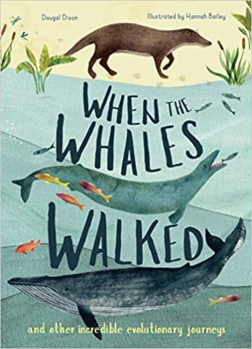 | Title: At Nine of the Night  Poet: Charley Causley  Title: the frozen man poet: Kit Wright  Title: Wings  Author: Pie Corbett  (The works 2 p187)  Content domain: visualisation | Title: Moth  Author: Isabel Thomas  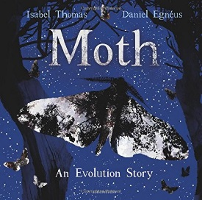  Content domain: 2d Inference
Spring 1  Curriculum driver: history – who has the right? | Title: A story like the Wind  author: Gill Lewis  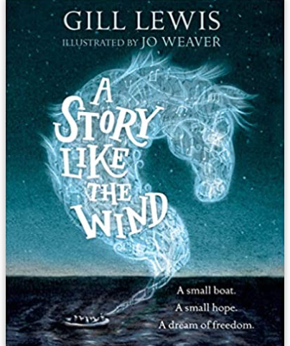  Title: The Island  Author: Armin Greder  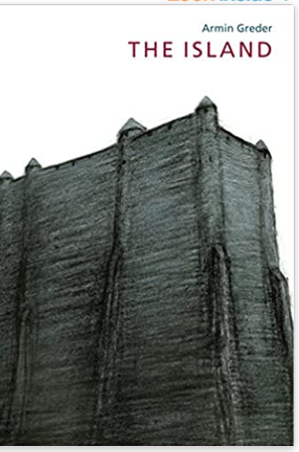  Title: Respect: the Walter Tull Story  Author: Michaela Morgan  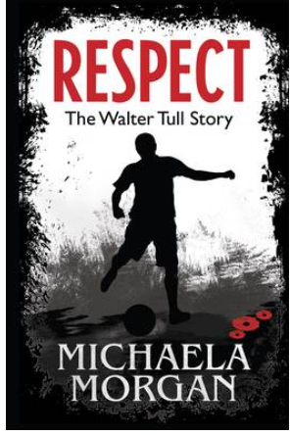  Title: Freedom  Author: Catherine Johnson  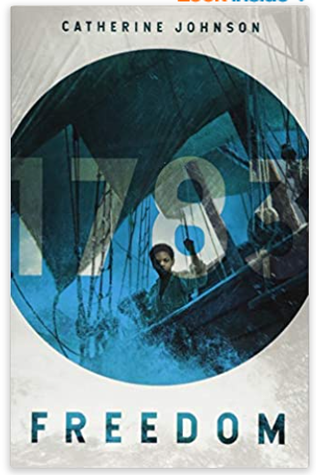 | Title: black and british  Author: David Olusoga  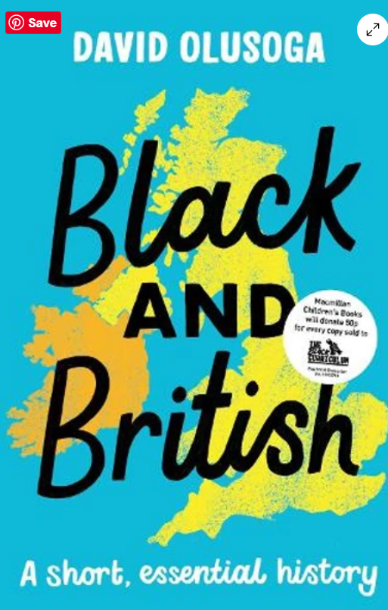  Title: Perfectly Imperfect Stories  Author:Leo Potion  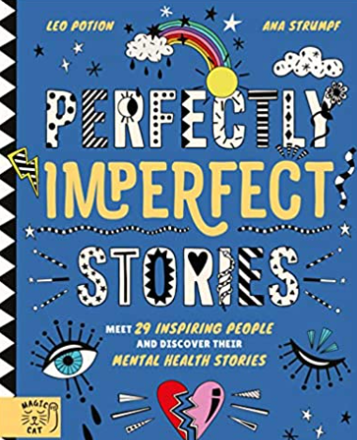  Title: singing for freedom  Author: Literacy Shed +  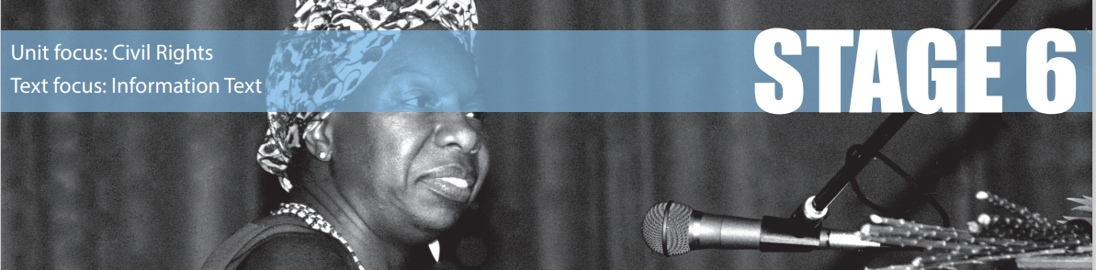  Title: Ruby Bridges: a schoolgirl who made history  Author: Literacy Shed +  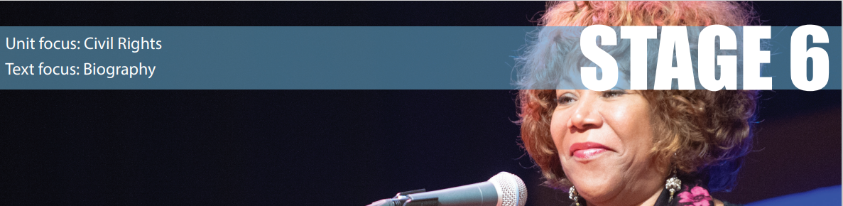 | Title: Refugees  Poet: Brian Billston  Title: still I rise (selected stanzas)  Poet: Maya Angelou  Title: Blowin in the Wind  Poet: Bob Dylan | Title Dreams of Freedom  Amnesty International  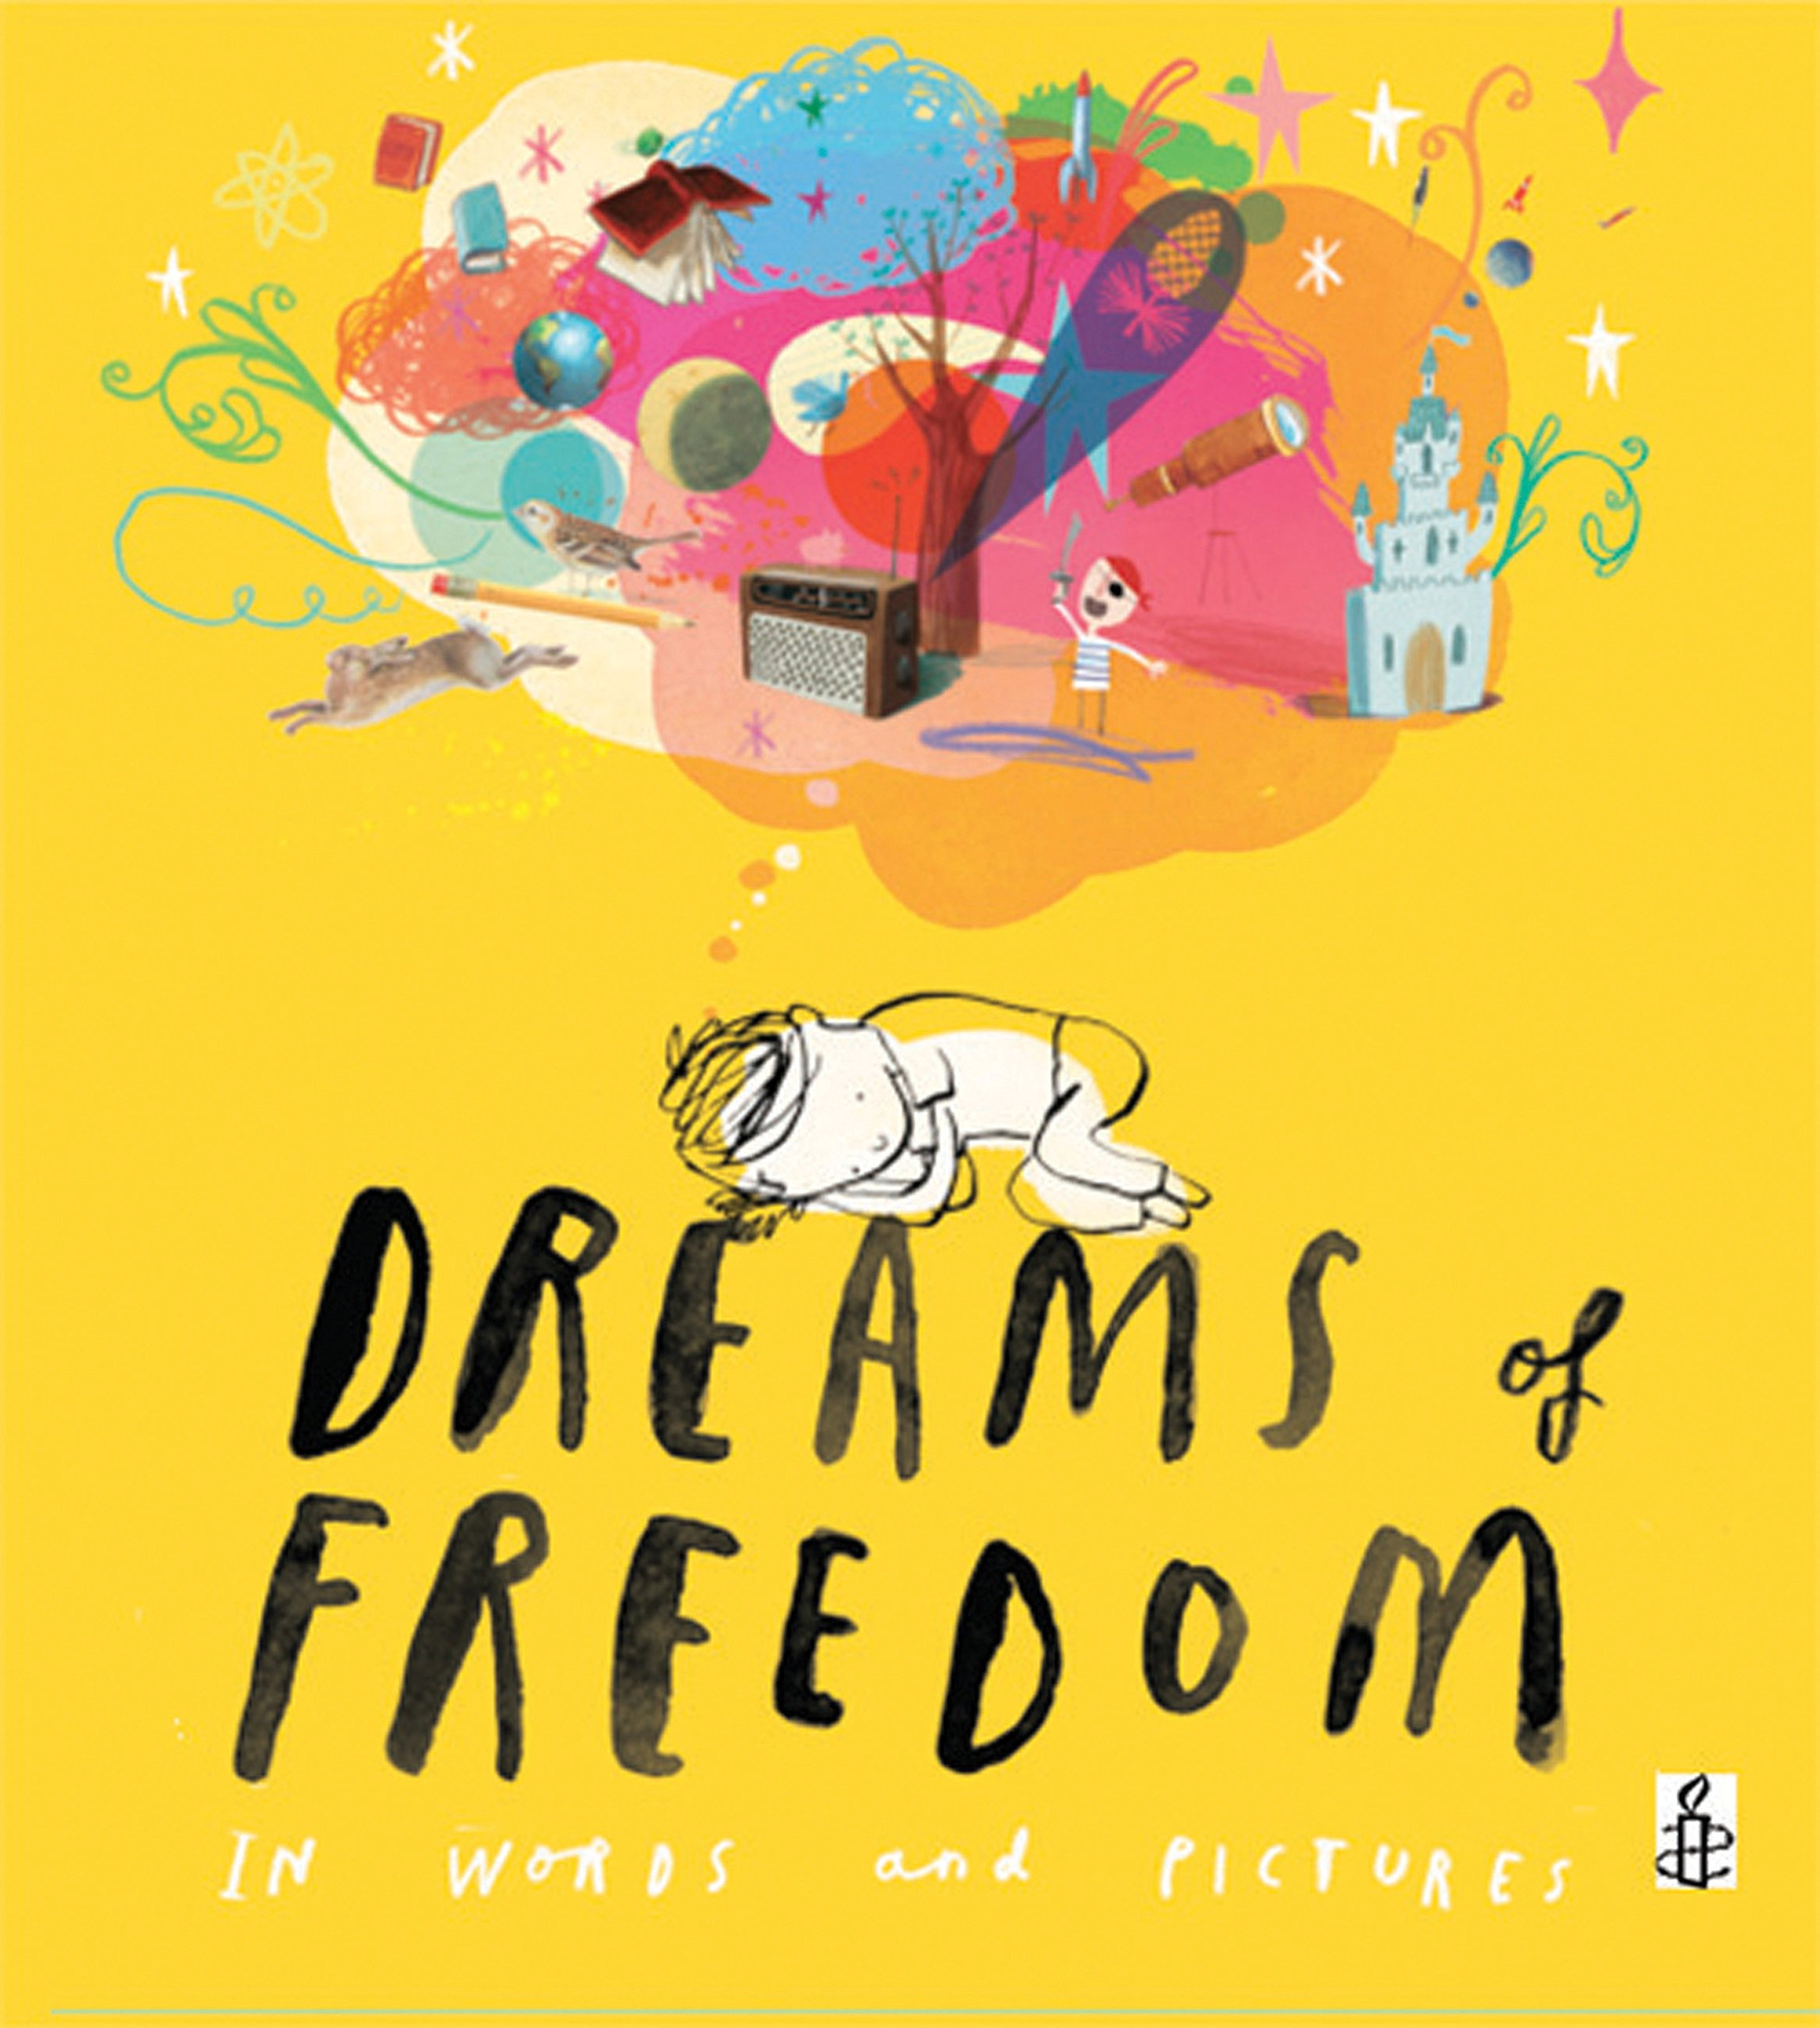  To recognise freedom  Content domain: Visualisation
Spring 2  Curriculum driver –  Science: electricity and light | Suspense openings:  Title: Wild Boy  Author: Rob Lloyd Jones  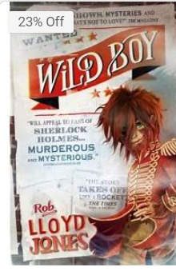  Title: The Girl who walked on Air  Author: Emma Carrol  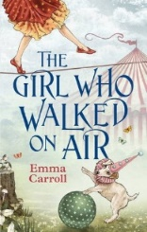  Title: The Last Spell Breather  Author: Julie Pike  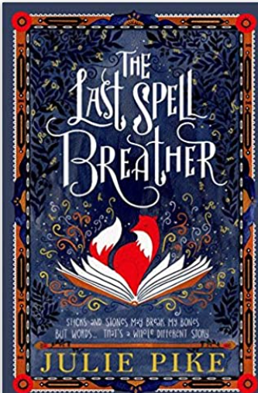  Content domain: 2g identify and explain language and 2h make comparisons | Title: Science is Magic  Author: Steve Mould  Title: Scientist Academy  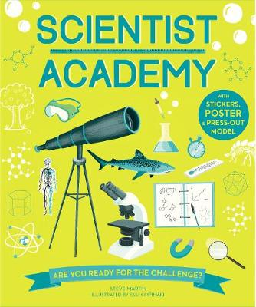  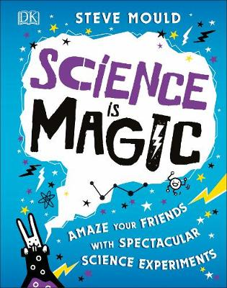  Author: Steve Martin  Literacy Shed:  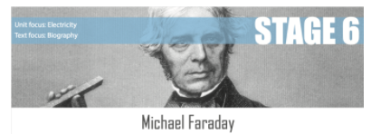  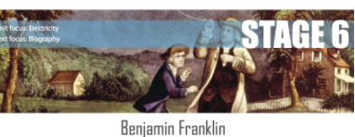  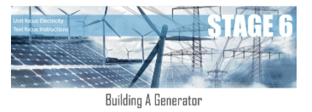  Content domain: 2c summarising/paraphrasing | Title: the land of counterpane  Poet: Robert Louis Stephenson  Title: Block City  Poet: Robert Louis Stephenson  Content domain: 2f – Explaining language and structure/analyse and evaluate (author) | Title: The Whisperer  Author: Nick Butterworth  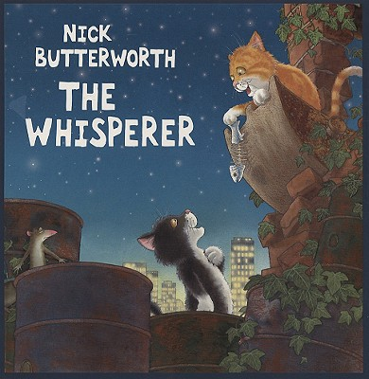
Summer 1 | Title: Morris Lessmore  Author: W E Joyce  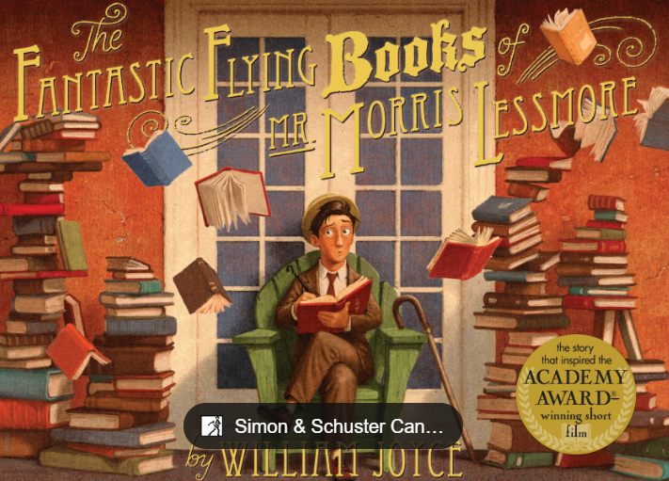  Title: The Word Collector  Author: Sonja Wimmer  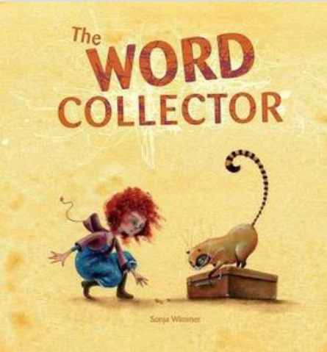  2a 2g Vocabulary/meaning of words | History of books:  A little history of reading: How the first books came to be | BookTrust  The evolution of the book | The Kid Should See This  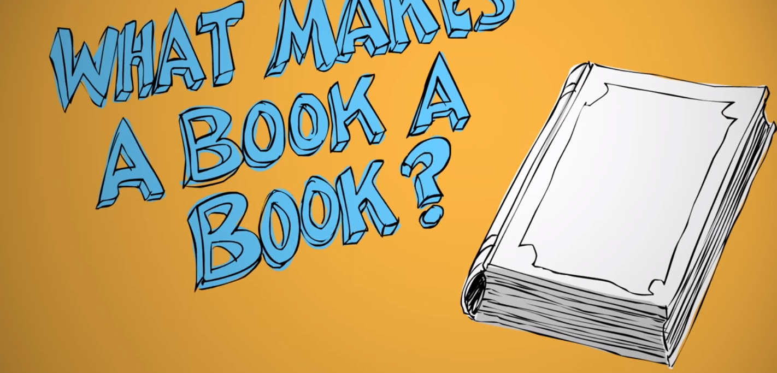  2b retrieval and 2c summarising | Title: There are things that lurk in the library  Poet: Joseph Coelho  Title: just words  Poet: matt Goodfellow (bright bursts of colour p22)  Title: Uses (Rachel Rooney –wonderland Alice in poetry p7)  The weaver of words (Sue Hardy-Dawson - where zebra’s go p8)  Title: my needs  Poet: JonArno Lawson  P171 (A World full of poems)  Title: surprise  Poet: Beverly McLouhland  P186 (A World full of poems)  2d inferring
Summer 2

