Vine Tree Primary School PSHE Long Term Overview
 | Autumn 1 | Autumn 2 | Spring 1 | Spring 2 | Summer 1 | Summer 2
EYFS | New Beginnings | Getting on and Falling Out | Relationships | Good to be Me | Going for Goals | Changes
No Outsiders in Our School Book Link |  | You choose by Nick Sharratt and Pippa Goodheart  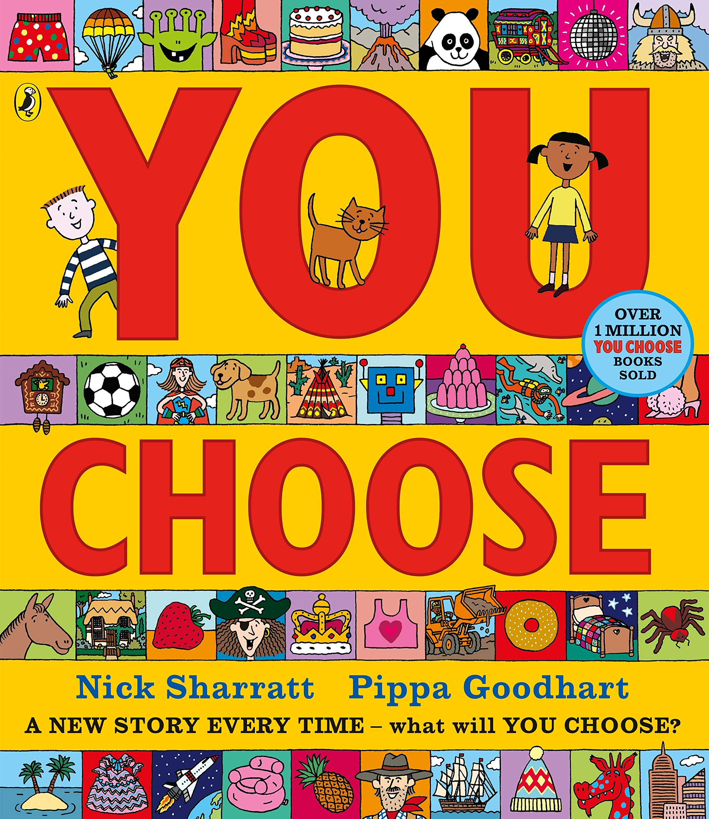 | Blue Chameleon by Emily Gravett  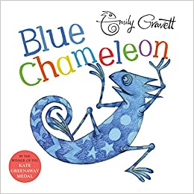 | 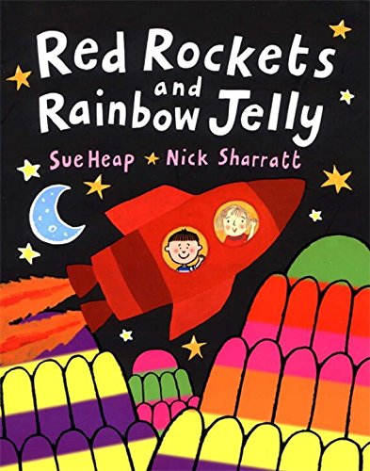  Red Rockets and Rainbow Jelly by Sue Heap and Nick Sharratt | The Family Book by Todd Parr  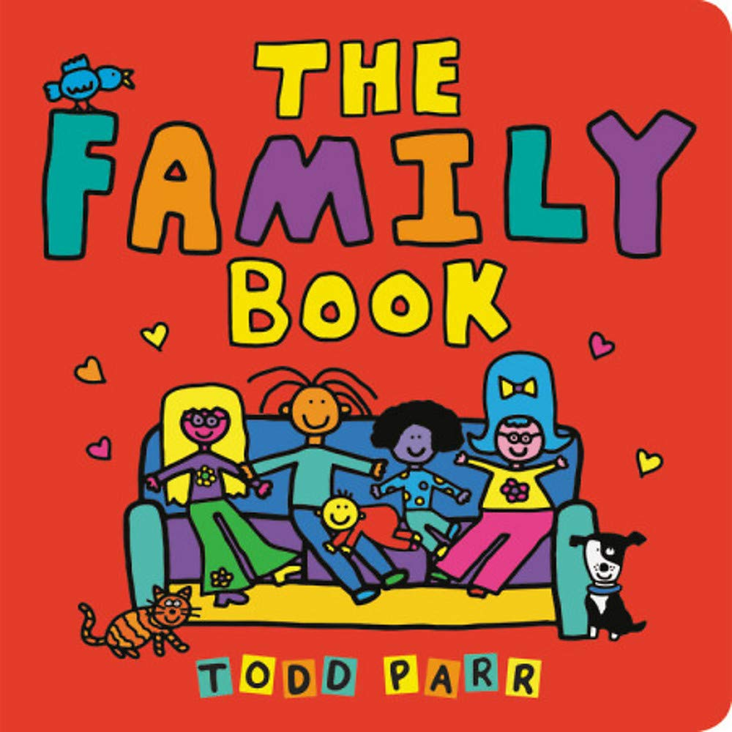 | Mommy Mama and Me by Leslea Newman and Carol Thompson  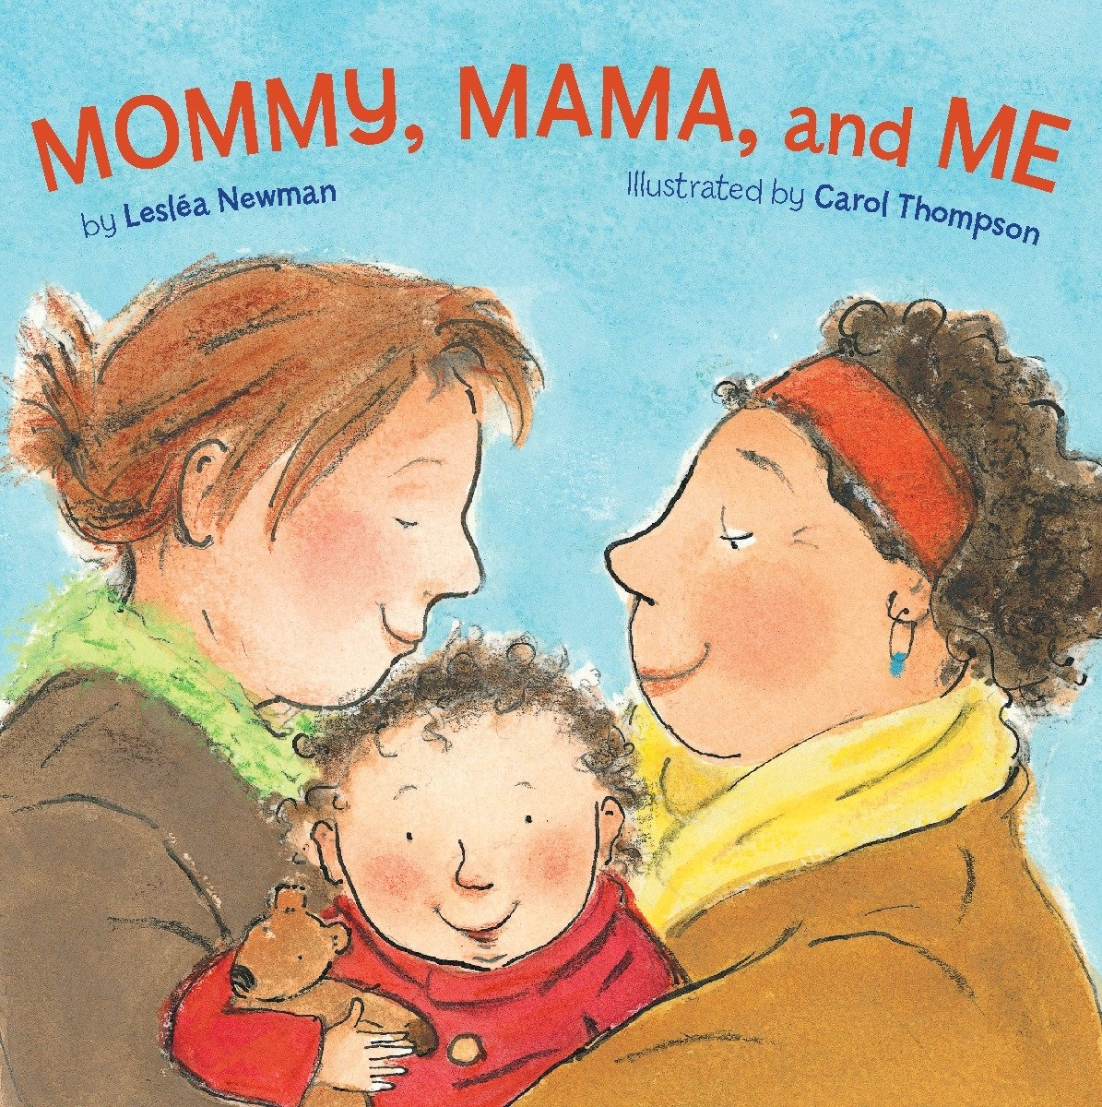
No Outsiders in our school Learning Intention |  | To say what I think | To make friends with someone different | To understand that it’s OK to like different things | To understand that all families are different | To celebrate my family
Year 1 | What is the same and different about us? | Who is special to us? | What helps us stay healthy? | What can we do with money? | Who helps us to keep safe? | How can we look after each other and the world?
No Outsiders in Our School Book Link | Elmer by David McKee  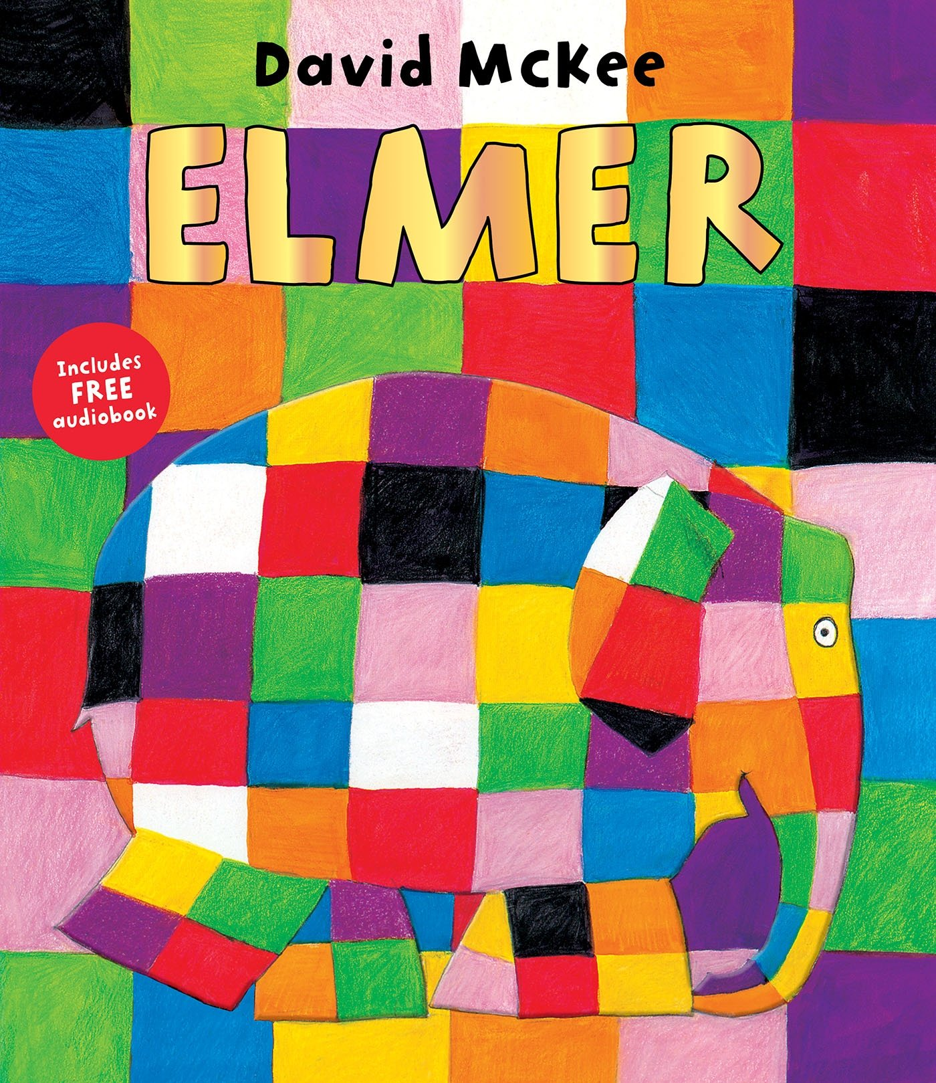 | My Grandpa is Amazing by Nick Butterworth  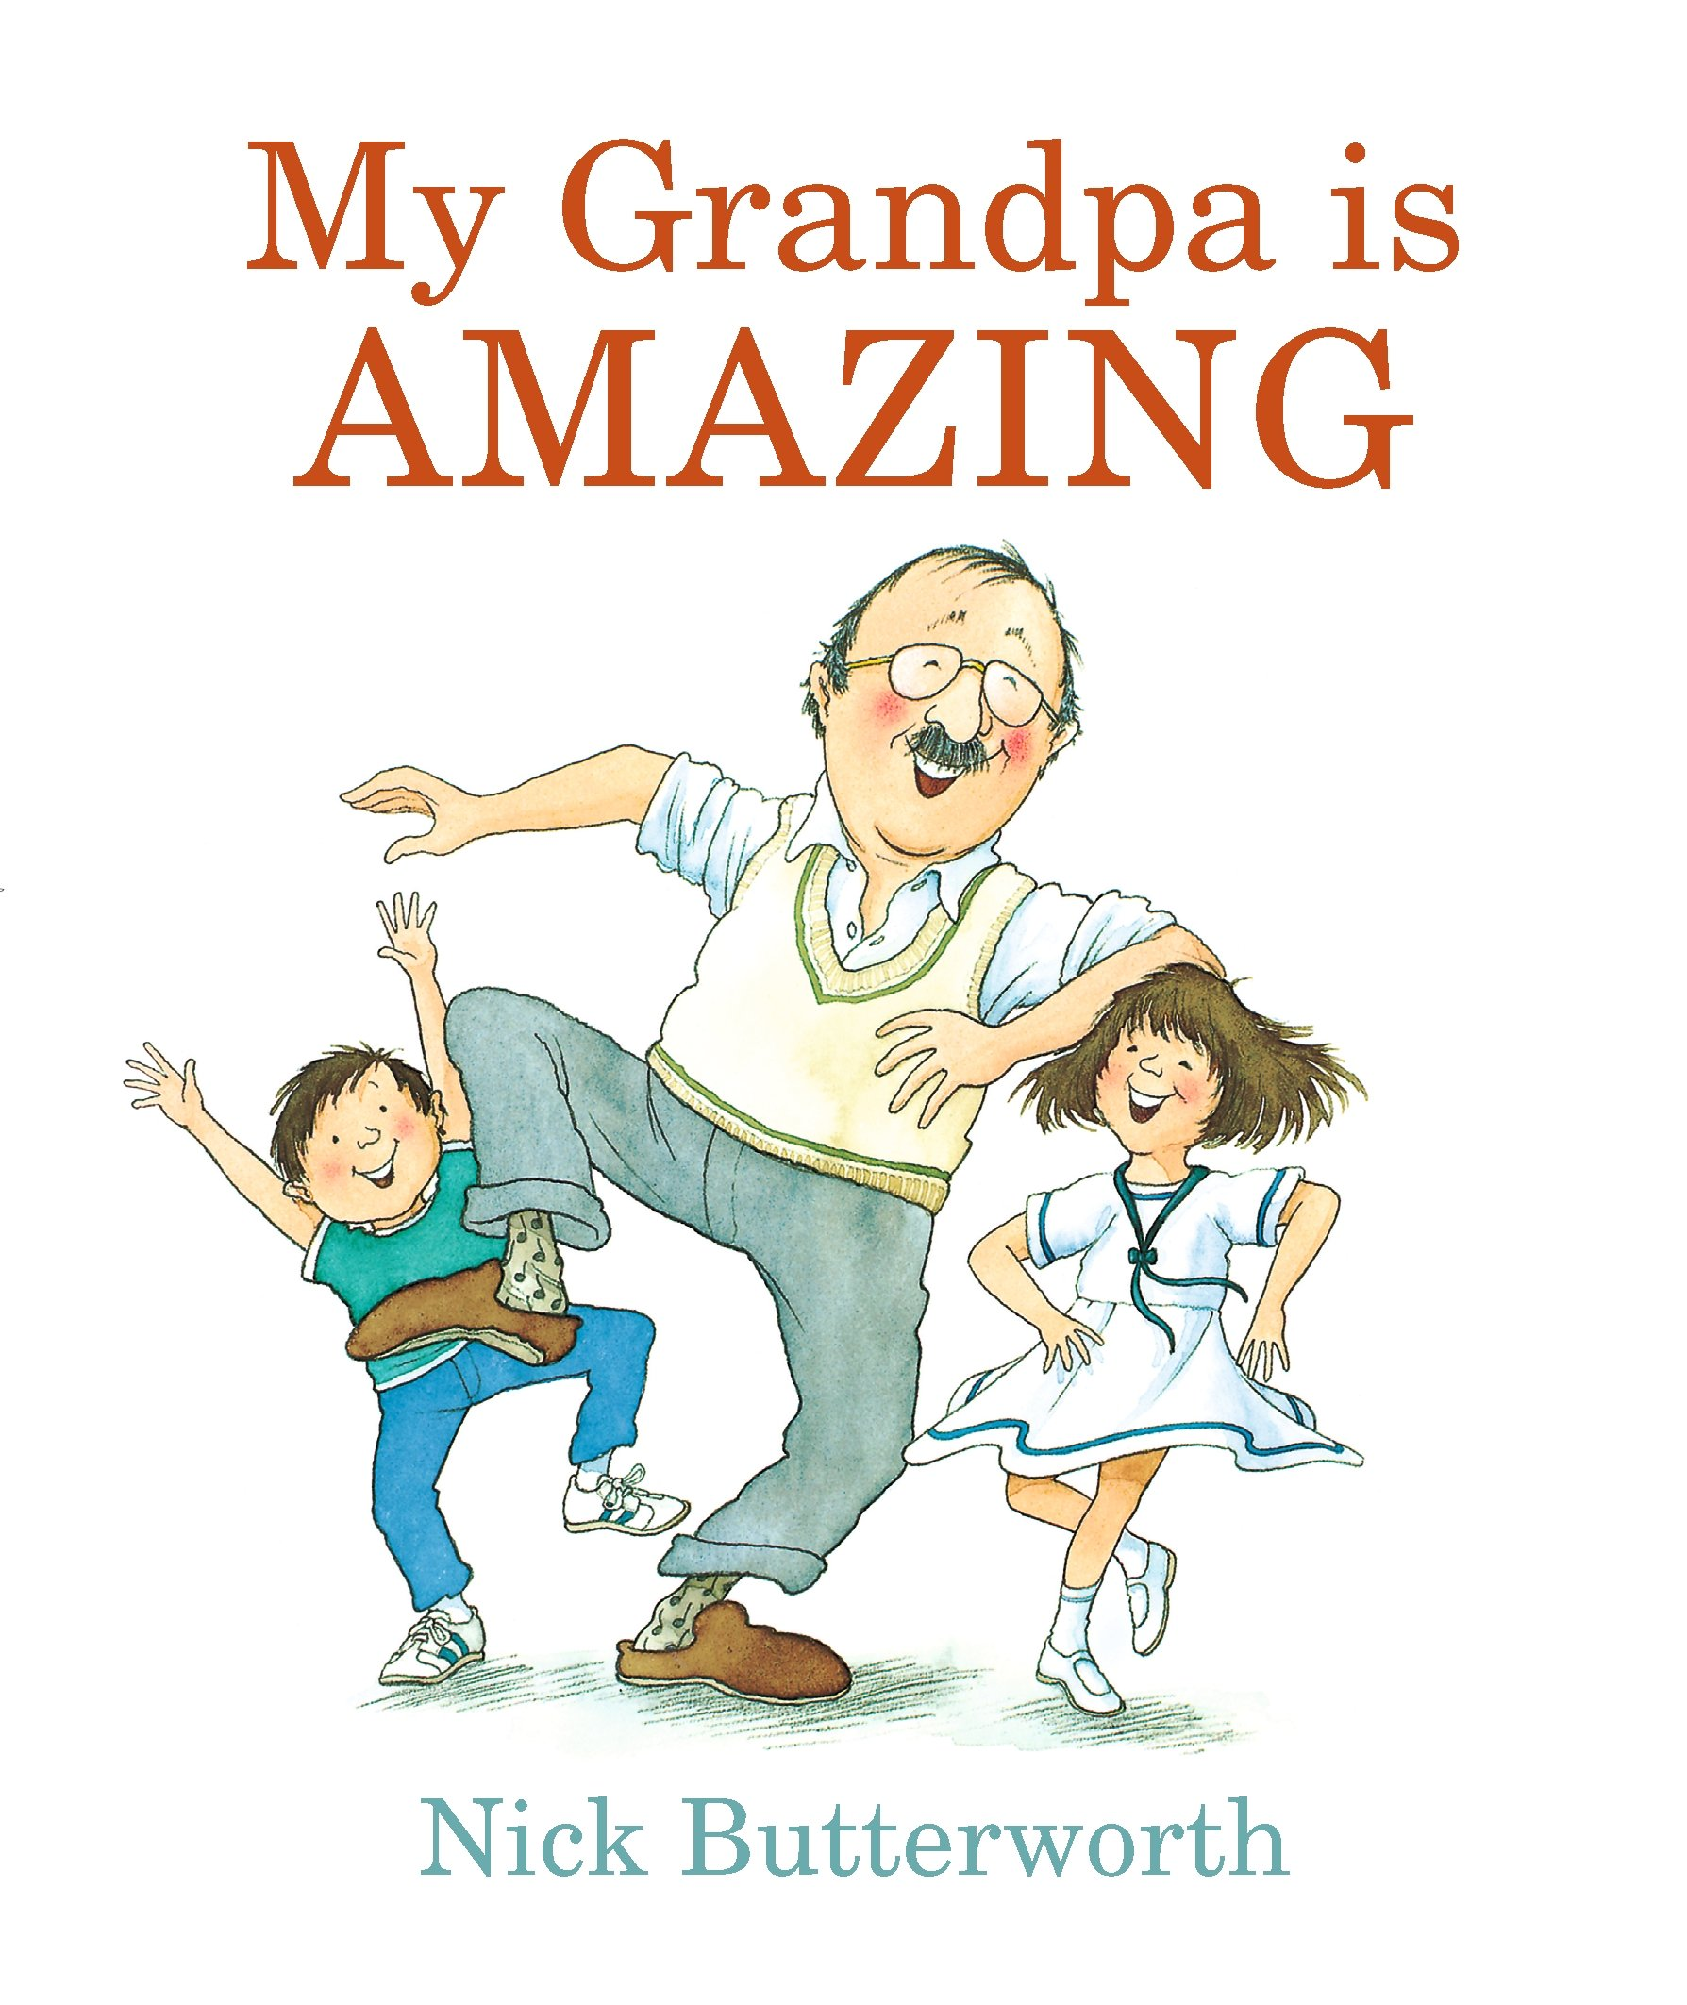 | Max the Champion by Sean Stockdale, Alexandra Strick and Ros Asquith  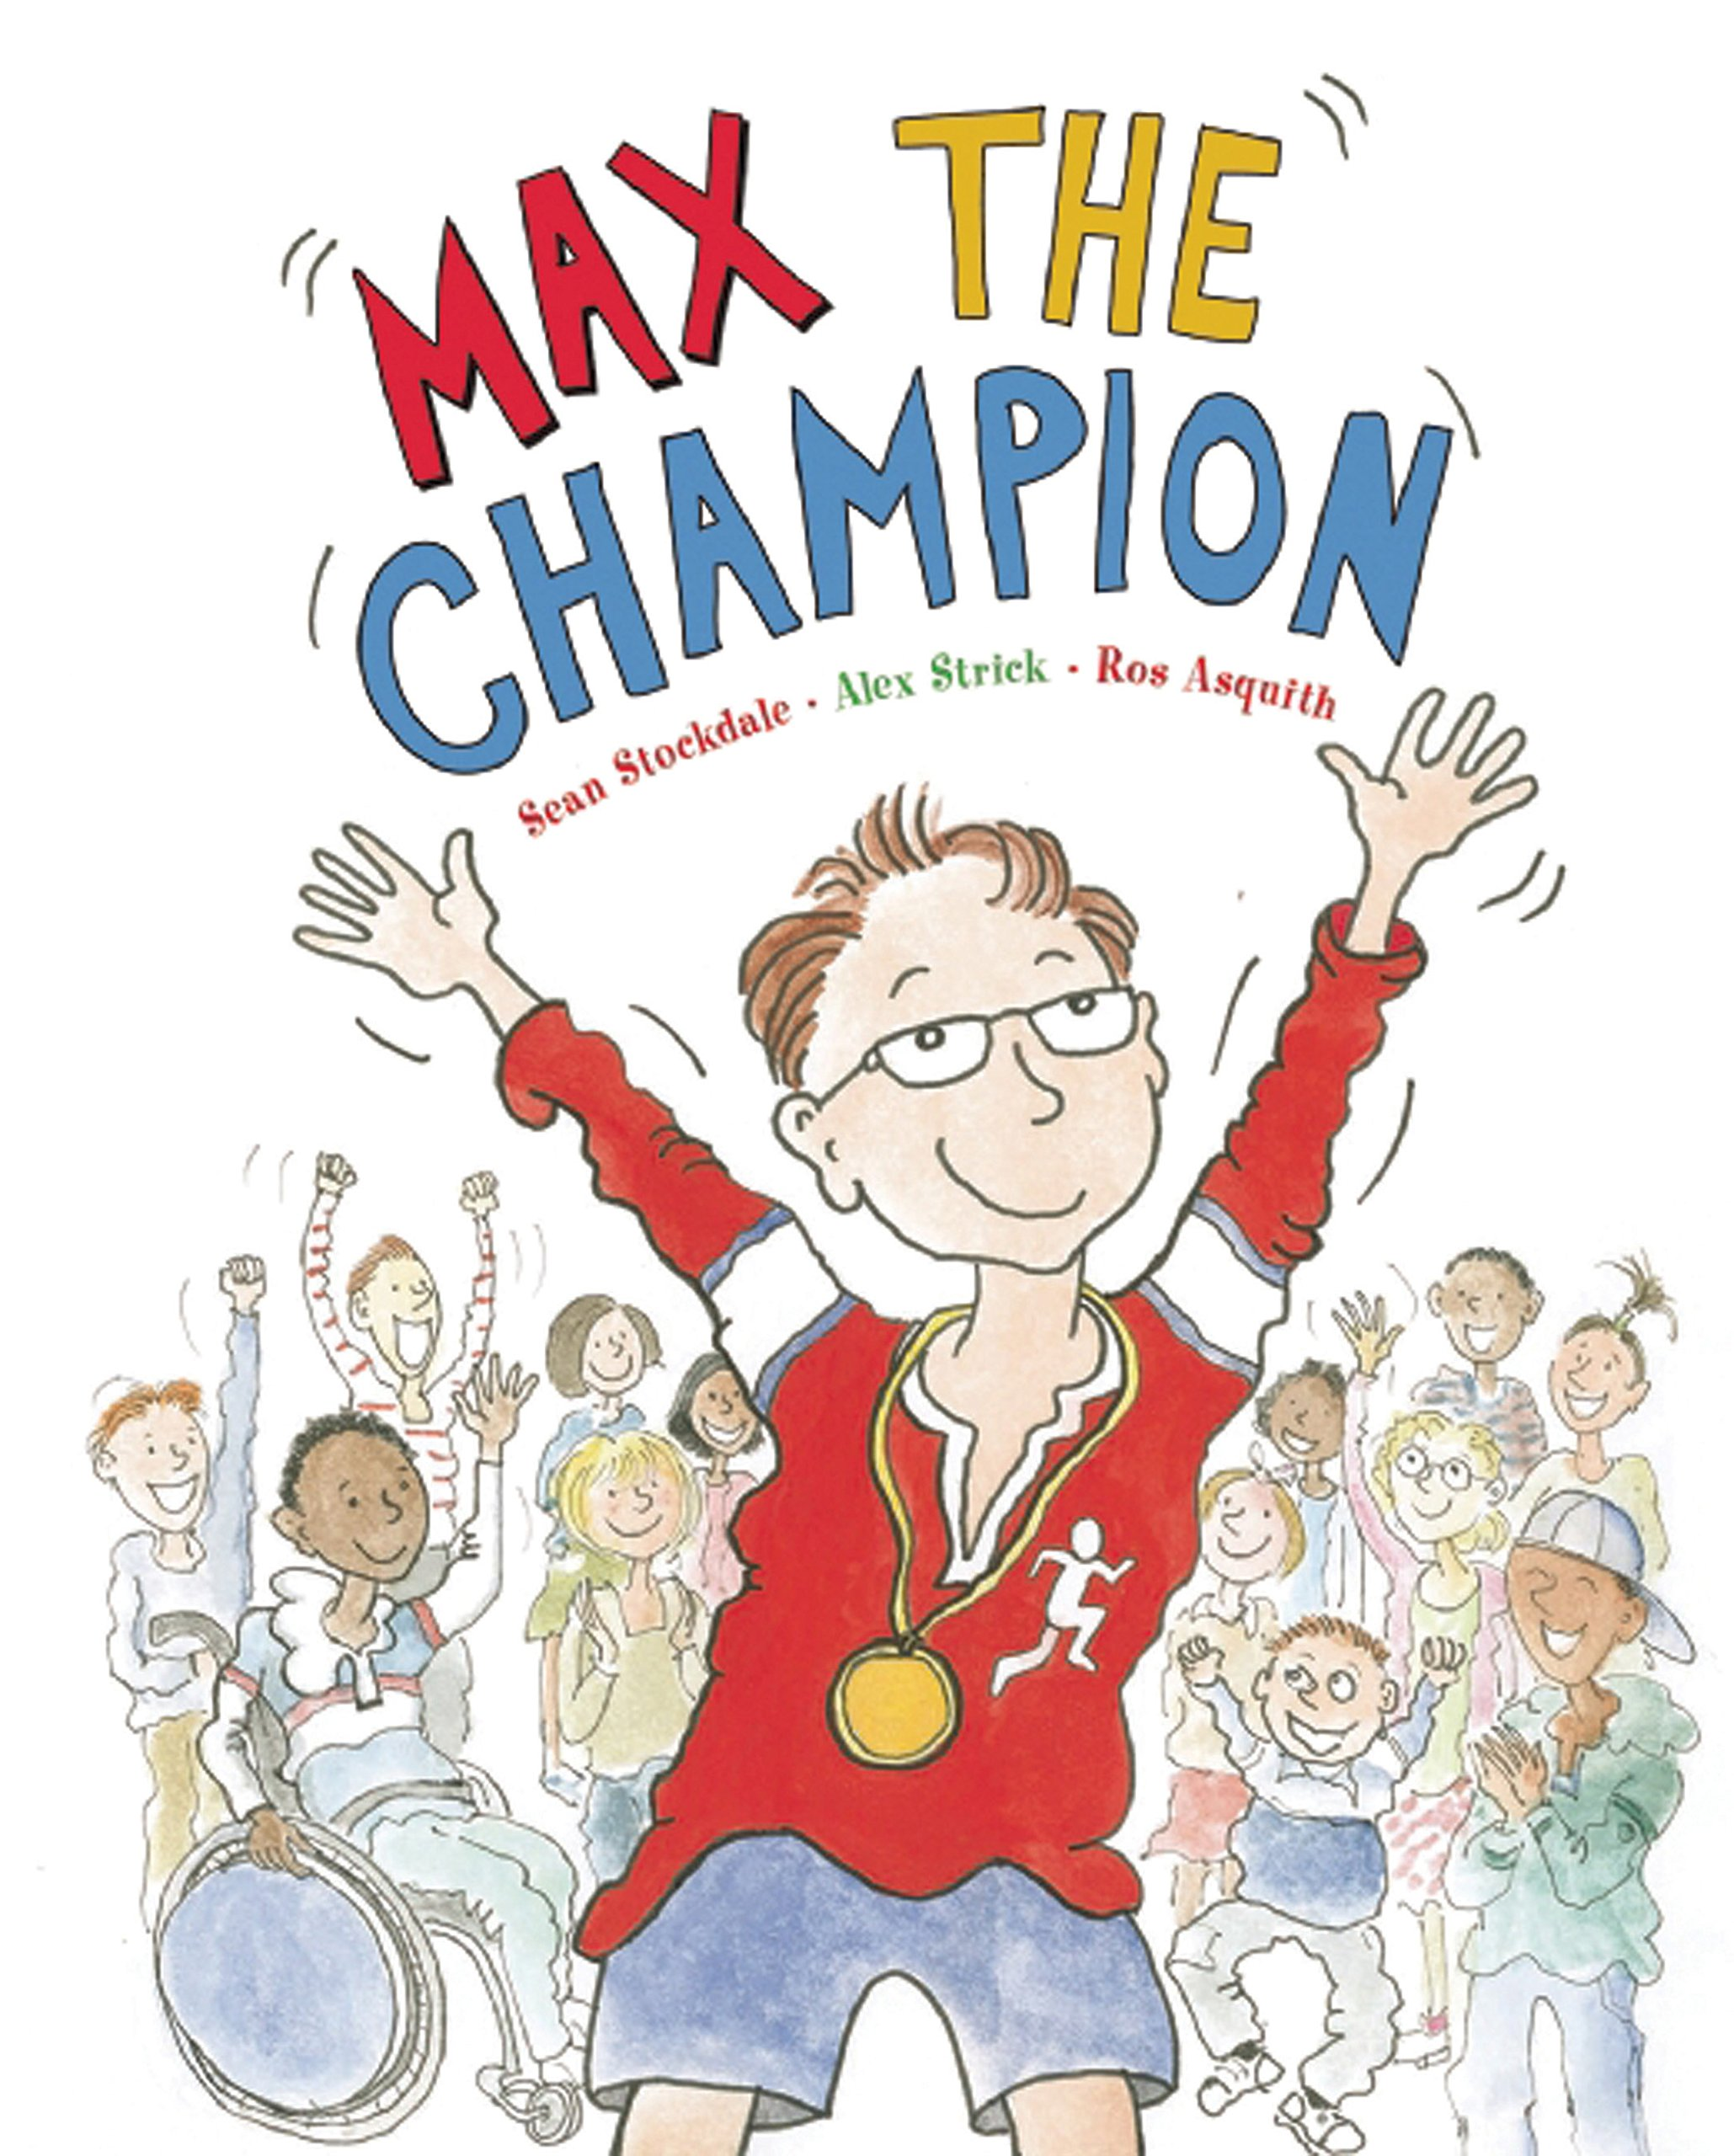 |  | Ten Little Pirates by Mike Brownlow and Simon Rickerty  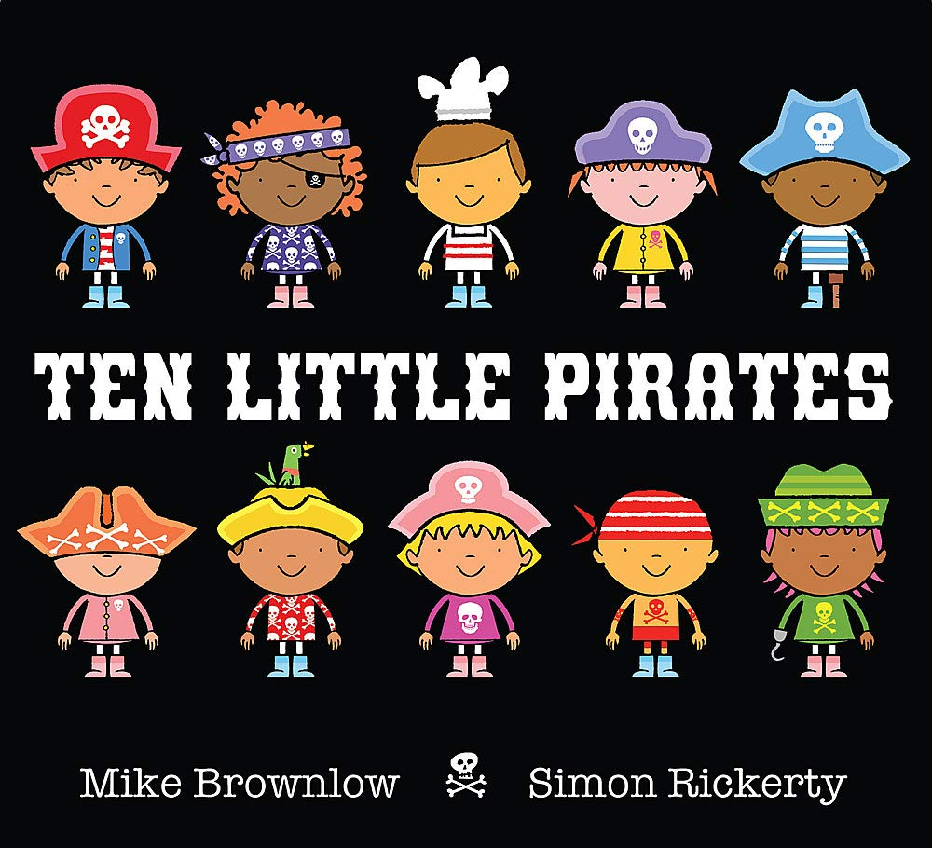 | My World, Your World by Melanie Walsh  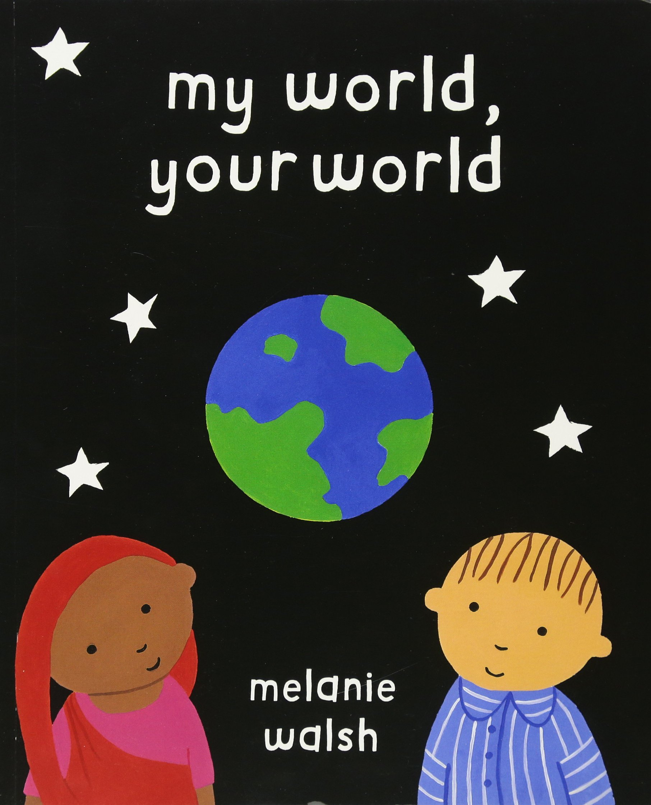
No Outsiders in our school Learning Intention | To like the way I am | To recognise that people are different ages | To understand that our bodies work in different ways |  | To play with boys and girl | To understand that we share the world with lots of pe
Year 2 | What makes a good friend? | What is bullying? | What jobs do people do? | What helps us to stay safe? | What helps us grow and stay healthy? | How do we recognise our feelings?
No Outsiders in Our School Book Link | 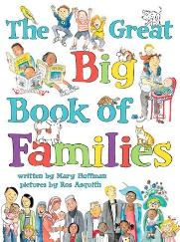  The Great big book of families by Mary Hoffman and Ros Asquith |  | The first Slodge by Jeanne Willis  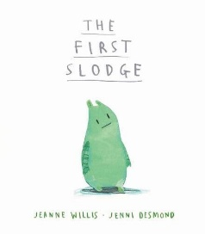 | The Odd Egg by Emily Gravett  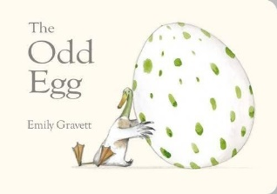 | Just Because by Rebecca Elliot  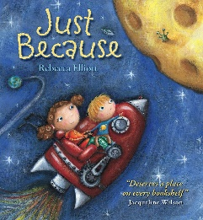 | Blown Away by Rob Biddulph  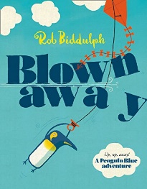
No Outsiders in our school Learning Intention | To understand what diversity is |  | To understand how we share the world | To understand what makes someone feel proud | To feel proud of being different | To be able to work with everyone in my class
Year 3 | How can we be a good friend? | What keeps us safe? | What are families like? | What makes a community? | Why should we eat well and look after our teeth? | Why should we keep active and sleep well?
No Outsiders in Our School Book Link | Beegu by Alexis Deacon  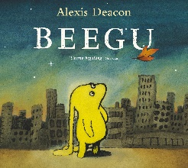 | Oliver by Birgitta Sif  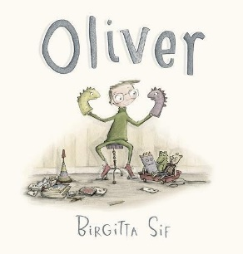 | Two Monsters by David McKee  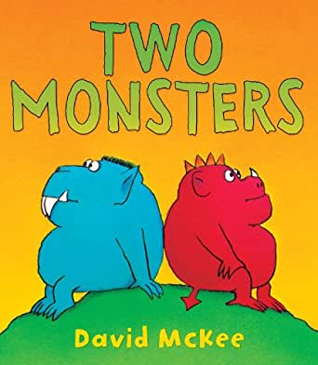 | This is Our House by Michael Rosen  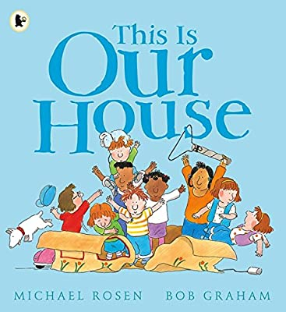 |  | The Hueys in the New Jumper by Oliver Jeffers  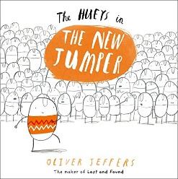
No Outsiders in our school Learning Intention | To be welcoming | To understand how difference can affect someone | To find a solution to a problem | To understand what ‘discrimination means’ |  | Use strategies to help someone who feels different
Year 4 | What strengths, skills and interests do we have? | How do we treat each other with respect? | How can we manage our feelings? | How will we grow and change? | How can our choices make a difference to others and the environment? | How can we manage risk in different places?
No Outsiders in Our School Book Link | Dogs don’t do ballet by Anna Kemp and Sara Ogilvie  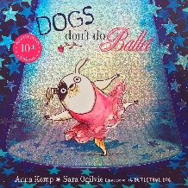 | The Way back home by Oliver Jeffers  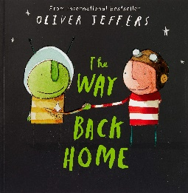 | King and King by Linda de Hann and Stern Nijland  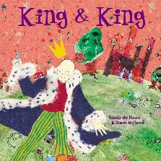 | The Flower by John Light  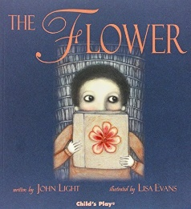 | Red: A Crayon’s Story by Michael Hall  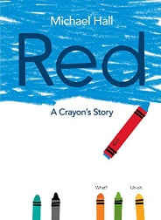
No Outsiders in our school Learning Intention | To know when to be assertive | To overcome language as a barrier | To understand why people choose to get married | To ask questions | To be who you want to be
Year 5 | What makes up a person’s identity? | What decisions can people make with money? | How can we help in an accident or emergency? | How can friends communicate safely? | How can drugs common to everyday life affect health? | What jobs would we like?
No Outsiders in Our School Book Link | And Tango Makes Three by Justin Richardson and Peter Parnell  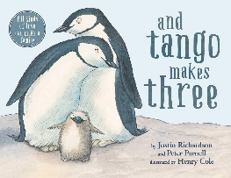 | Where the Poppies Now Grow by Hilary Robinson and Martin Impey  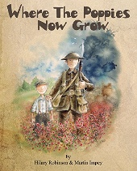 | How to Heal a Broken Wing by Bob Graham  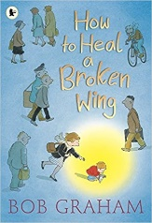 | Rose Blanche by Ian McEwan and Roberto Innocenti  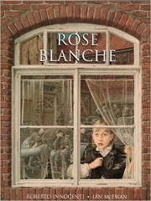 |  | The Artist who Painted a Blue Horse by Eric Carle  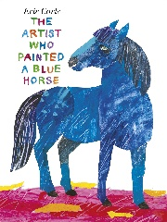
No Outsiders in our school Learning Intention | To accept people who are different from me | To learn from our past | To recognise when someone needs help | To justify my actions |  | To appreciate artistic freedom
Year 6 | How can we keep healthy as we grow? |  | How can the media influence people? |  | What will change as we become more independent?  How do friendships change as we grow?
No Outsiders in Our School Book Link | Love you forever by Robert Munsch  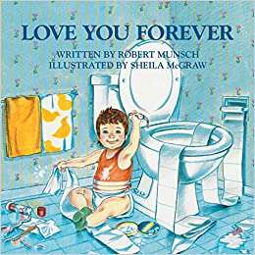 |  | My Princess Boy by Cheryl Kilodavis and Suzanne DeSimone  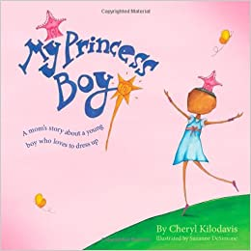 | The Whisperer by Nick Butterworth  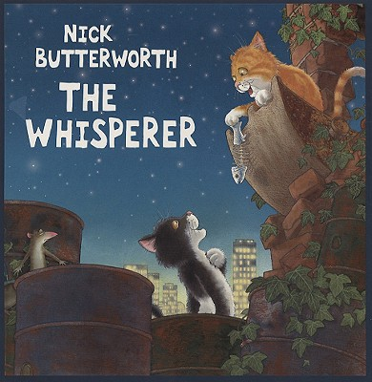 | The Island by Armin Greder  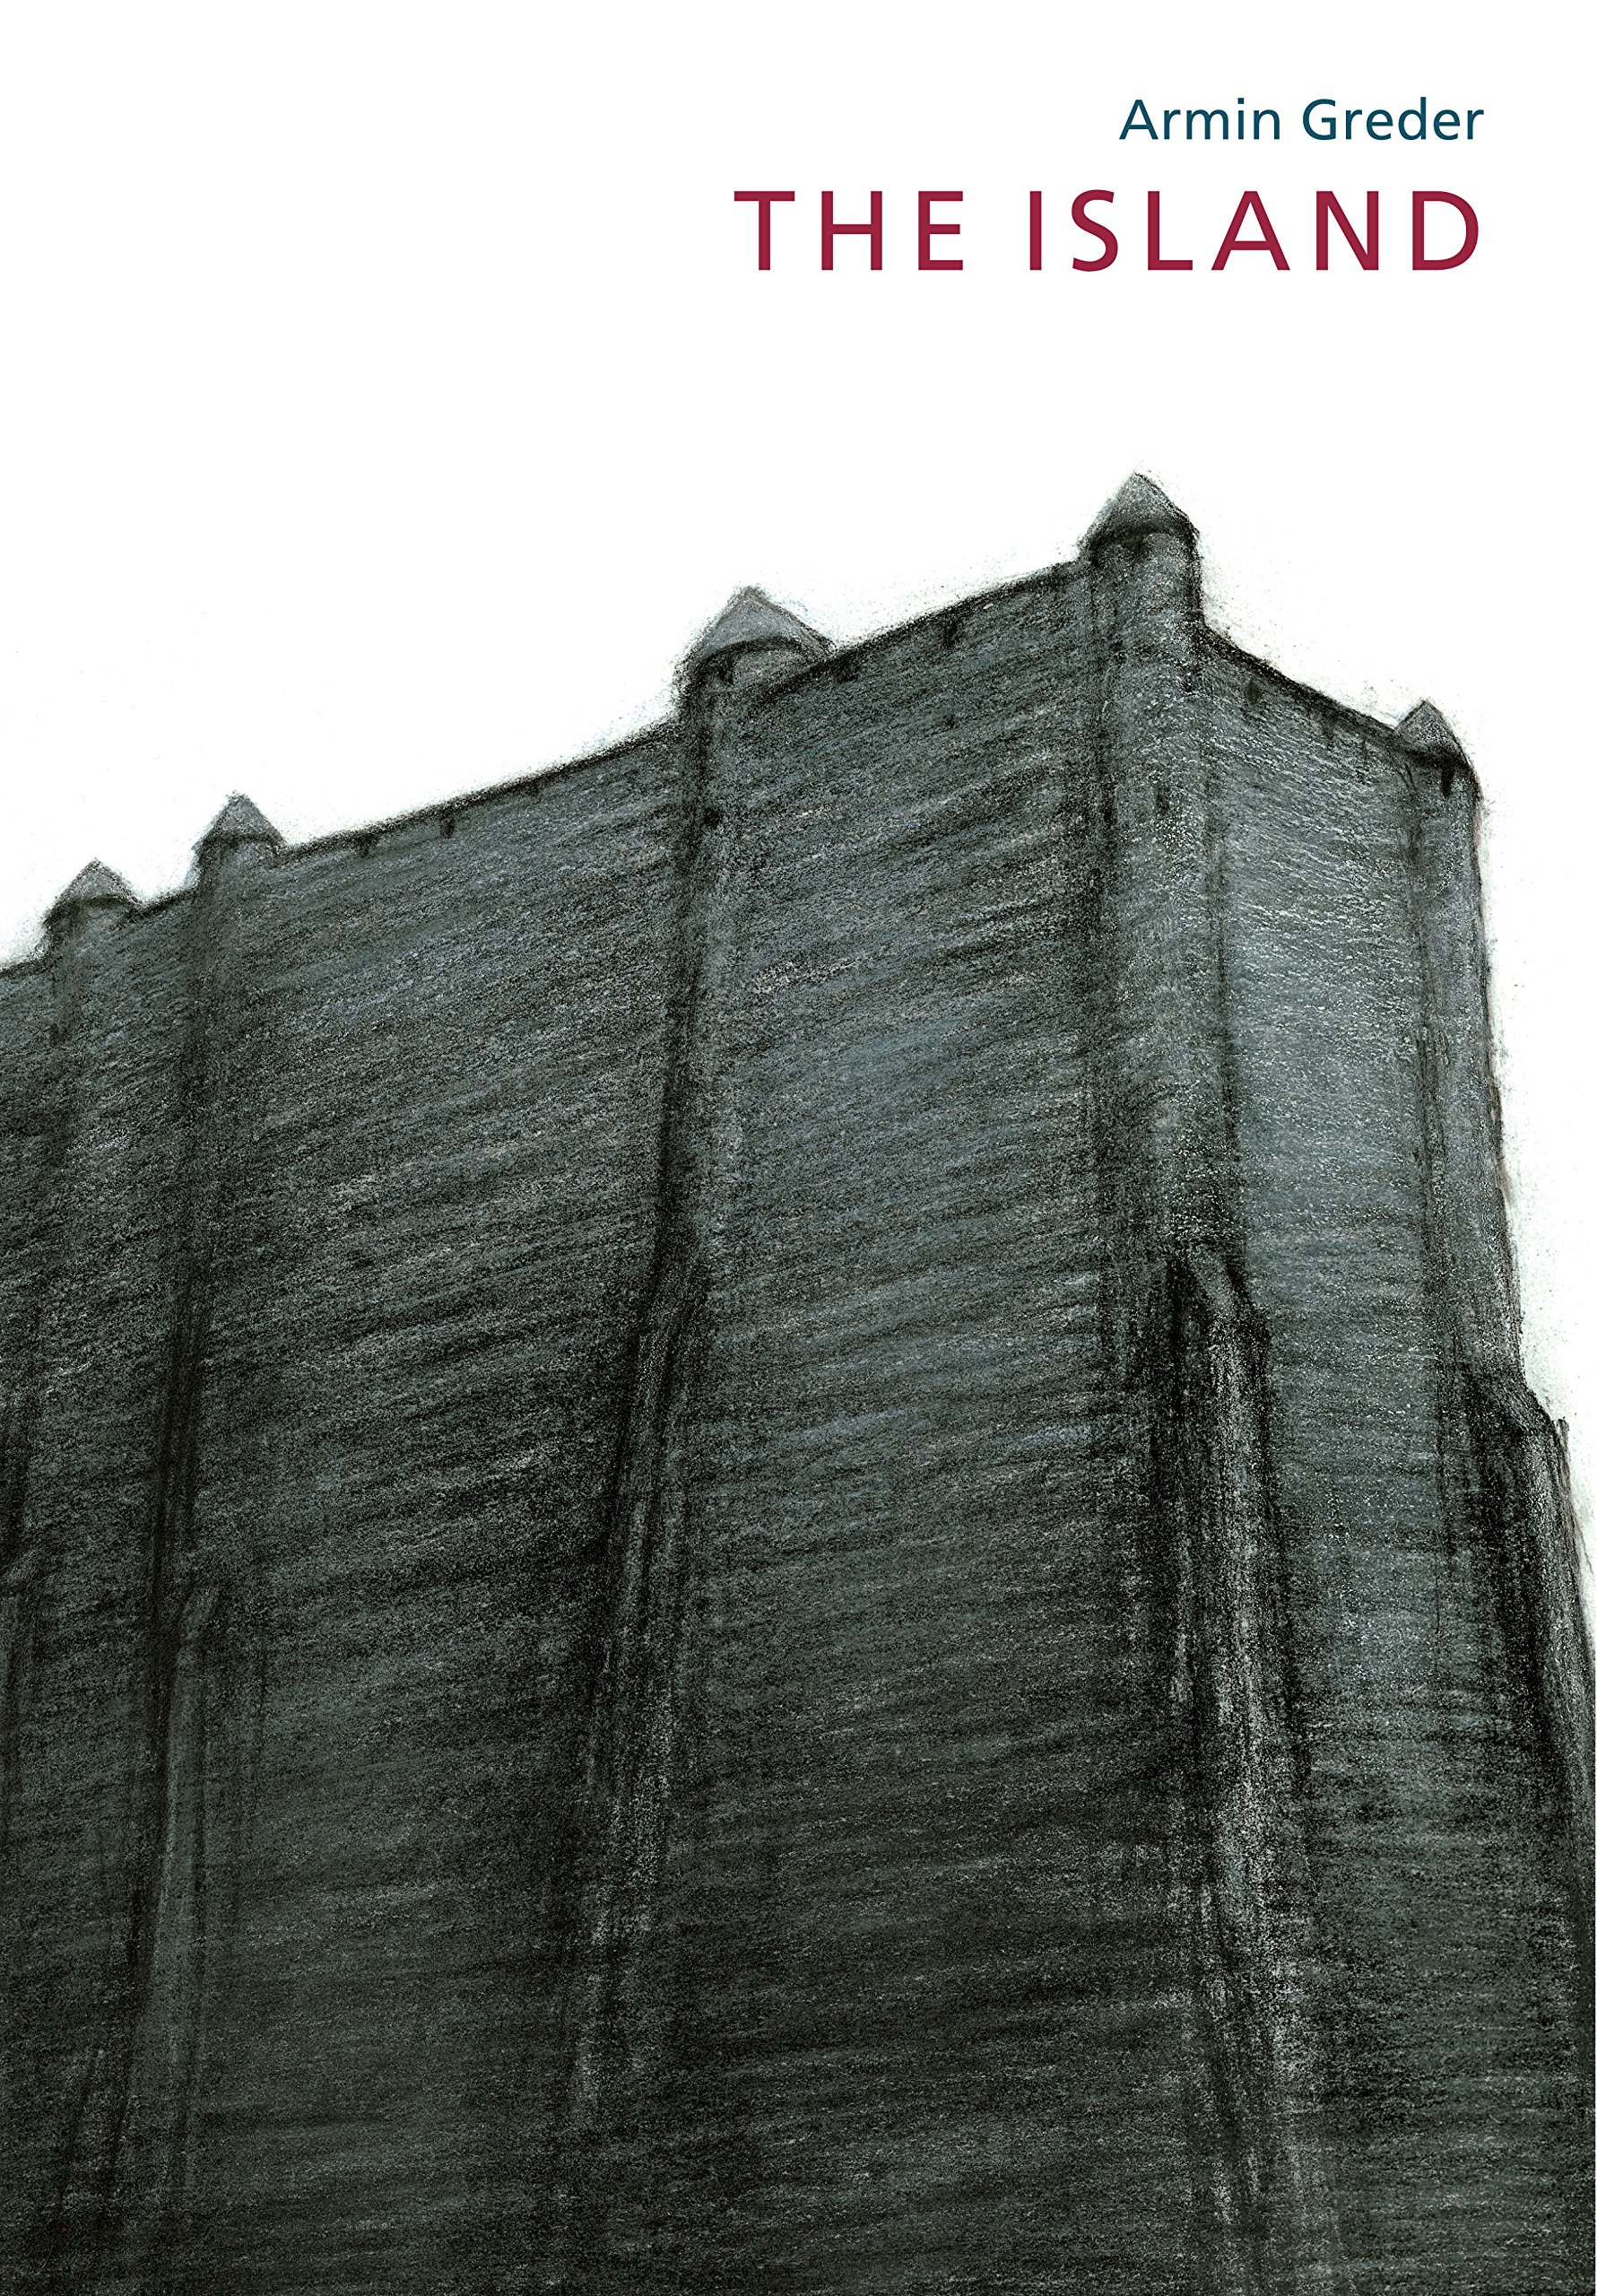 | Dreams of Freedom by Amnesty International  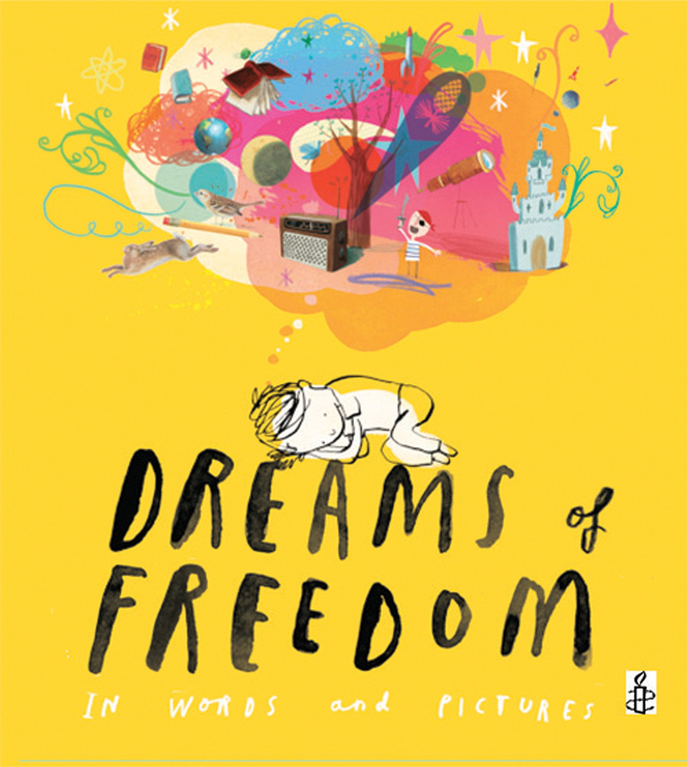
No Outsiders in our school Learning Intention | To consider how my life may change as I grow up |  | To promote diversity | To stand up to discrimination | To challenge the causes of racism | To recognise my freedom

Health and Well-being | Relationships | Living in the Wider World

