Relationships and Sex Education policy

Vine Tree Primary School

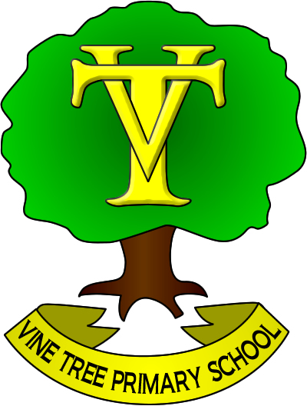

|  |  |  |
| --- | --- | --- |
| **Approved by: Governors** |  | **Date:** October 2023 |
| **Last reviewed on: Sept 2024** |  | |
| **Next review due by:** | October 2025 | |

# 1. Intent

The aims of relationships and sex education (RSE) at our school are to:

* Provide a framework in which sensitive discussions can take place
* Prepare pupils for puberty, and give them an understanding of sexual development and the importance of health and hygiene
* Help pupils develop feelings of self-respect, confidence and empathy
* Create a positive culture around issues of sexuality and relationships
* Teach pupils the correct vocabulary to describe themselves and their bodies
* To promote diversity within our school and the wider community
* To ensure that pupils can recognise the importance of their own safety and well-being and know ways to get help when needed

# 2. Statutory requirements

As a maintained primary school we must provide relationships education to all pupils as per section 34 of the [Children and Social work act 2017.](http://www.legislation.gov.uk/ukpga/2017/16/section/34/enacted)

However, we are not required to provide sex education, but we do need to teach the elements of sex education contained in the science curriculum (Appendix 5)

In teaching RSE, we must have regard to [guidance](https://www.gov.uk/government/consultations/relationships-and-sex-education-and-health-education) issued by the secretary of state as outlined in section 403 of the [Education Act 1996.](http://www.legislation.gov.uk/ukpga/1996/56/contents) The outcomes of which are listed in Appendix 4.

At Vine Tree Primary School we teach RSE as set out in this policy.

# 3. Policy development

This policy has been developed in consultation with staff, pupils and parents. The consultation and policy development process involved the following steps:

1. Pupil consultation – we investigated what exactly pupils want from their RSE
2. Parent Consultation – we investigated what parents felt was important to include in our RSE curriculum
3. Staff Consultation – Staff were consulted on their thoughts and feelings regarding the content of the RSE curriculum
4. Review – the PSHE lead teacher pulled together all relevant information including relevant national and local guidance
5. Parent/stakeholder consultation – parents, staff and any interested parties were invited to share their feedback on the RSE Policy and its associated curriculum
6. Ratification – once amendments were made, the policy was shared with governors and ratified

# 

# 4. Definition

RSE is about the emotional, social and cultural development of pupils, and involves learning about relationships, sexual health, sexuality, healthy lifestyles, diversity and personal identity.

RSE involves a combination of sharing information, and exploring issues and values.

RSE is not about the promotion of sexual activity.

# 5. Curriculum

Our curriculum is set out as per Appendix 1 but we may need to adapt it as and when necessary.

We have developed the curriculum in consultation with parents, pupils and staff, taking into account the age, needs and feelings of pupils. If pupils ask questions outside the scope of this policy, teachers will respond in an appropriate manner so they are fully informed and don’t seek answers online.

Primary sex education will focus on:

* Preparing boys and girls for the changes that adolescence brings
* How a baby is conceived and born

For more information about our curriculum, see Appendix 1 and 2

# 6. Implementation

RSE is taught within the personal, social, health and economic (PSHE) education curriculum. Biological aspects of RSE are taught within the science curriculum, and other aspects are included in religious education (RE).

Pupils may also receive stand-alone sex education sessions delivered by a trained health professional.

Relationships education focuses on teaching the fundamental building blocks and characteristics of positive relationships including:

* Families and people who care for me
* Caring friendships
* Respectful relationships
* Online relationships
* Being safe

In addition to the Science National Curriculum, Vine Tree Primary School teach sex education following the Medway Primary PSHE Education Relationships and Sex Education scheme of work. An overview of what is taught and at which point it is taught can be found in Appendices 1 and 2.

These areas of learning are taught within the context of family life taking care to ensure that there is no stigmatisation of children based on their home circumstances (families can include single parent families, LGBT parents, families headed by grandparents, adoptive parents, foster parents/carers amongst other structures) along with reflecting sensitively that some children may have a different structure of support around them (for example: looked after children or young carers).

# 7. Roles and responsibilities

7.1 The governing board

The governing board will approve the RSE policy, and hold the headteacher to account for its implementation.

7.2 The headteacher

The headteacher is responsible for ensuring that RSE is taught consistently across the school, and for managing requests to withdraw pupils from [non-statutory/non-science] components of RSE (see section 8).

7.3 Staff

Staff are responsible for:

* Delivering RSE in a sensitive way
* Modelling positive attitudes to RSE
* Monitoring progress
* Responding to the needs of individual pupils
* Responding appropriately to pupils whose parents wish them to be withdrawn from the [non-statutory/non-science] components of RSE

Staff do not have the right to opt out of teaching RSE. Staff who have concerns about teaching RSE are encouraged to discuss this with the headteacher.

7.4 Pupils

Pupils are expected to engage fully in RSE and, when discussing issues related to RSE, treat others with respect and sensitivity.

# 8. Parents’ right to withdraw

Parents do not have the right to withdraw their children from relationships education.

Parents have the right to withdraw their children from the [non-statutory/non-science] components of sex education within RSE.

Requests for withdrawal should be put in writing using the form found in Appendix 3 of this policy and addressed to the headteacher.

Alternative work will be given to pupils who are withdrawn from sex education.

# 9. Training

Staff are trained on the delivery of RSE as part of their induction and it is included in our continuing professional development calendar.

The headteacher will also invite visitors from outside the school, such as school nurses or sexual health professionals, to provide support and training to staff teaching RSE when necessary.

**10. Resources**

We follow the resources and guidance outlined in the PSHE association Programme of Study. This is organised into three themes: Health and Wellbeing, Relationships and Living in the Wider world and contains many resources created by the PSHE association. Lessons may also include resources published by:

The Medway Public Health Directorate (appendix 2)

NSPCC (<https://learning.nspcc.org.uk/research-resources/schools/pants-teaching>)

The Metro Charity (<https://metrocharity.org.uk/youth/hbt-anti-bullying-programme>)

The Alzheimer’s Society <https://www.alzheimers.org.uk/get-involved/dementia-friendly-communities/dementia-teaching-resources>

Think U Know <https://www.thinkuknow.co.uk/professionals/resources/>

The Red Cross <https://lifeliveit.redcross.org.uk/>

Coram Life Education <https://www.coramlifeeducation.org.uk/adoptables/>

Premier League Primary Stars <https://plprimarystars.com/>

Worcester University

Betty for schools <https://bettyforschools.co.uk/resources>

RSPCA <https://education.rspca.org.uk/education/teachers/primary/compassionateclass>

Giving help to others <http://givingtohelpothers.org/>

Parentzone <https://parentzone.org.uk/legendshome>

Rise Above <https://campaignresources.phe.gov.uk/schools/topics/rise-above/overview?WT.mc_id=RiseAboveforSchools_PSHEA_EdComs_Resource_listing_Sep17>

CBBFC <https://www.cbbfc.co.uk/grown-ups/free-pshe-primary-school-lesson-plans>

Childnet <https://www.childnet.com/resources/trust-me>

This list will be reviewed and other age appropriate resources may be used.

Alongside the PSHE Associate programme of study, RSE/ PSHE lessons will include lessons to teach the Equality Act using the ‘No Outsiders in Our School’ scheme of work published by Andrew Moffatt. This uses a range of children’s picture books to teach a range of themes as outlined in Appendix 1.

# 11. Monitoring arrangements

The delivery of RSE is monitored by the Senior Leadership team through:

planning scrutinies, learning walks, book looks and pupil feedback

Pupils’ development in RSE is monitored by class teachers as part of our internal assessment systems.

This policy will be reviewed by Mr Ashley Holt (PSHE Lead) annually. At every review, the policy will be approved by the governing board.

### Appendix 1: Curriculum map (Long term plan)

|  |  |  |  |  |  |  |
| --- | --- | --- | --- | --- | --- | --- |
|  | Autumn 1 | Autumn 2 | Spring 1 | Spring 2 | Summer 1 | Summer 2 |
| EYFS | New Beginnings | Getting on and Falling Out | Relationships | Good to be Me | Going for Goals | Changes |
| No Outsiders in Our School Book Link |  | You choose by Nick Sharratt and Pippa Goodheart | Blue Chameleon by Emily Gravett | Red Rockets and Rainbow Jelly by Sue Heap and Nick Sharratt | The Family Book by Todd Parr | Mommy Mama and Me by Leslea Newman and Carol Thompson |
| No Outsiders in our school Learning Intention |  | To say what I think | To make friends with someone different | To understand that it’s OK to like different things | To understand that all families are different | To celebrate my family |
| Year 1 | What is the same and different about us? | Who is special to us? | What helps us stay healthy? | What can we do with money? | Who helps us to keep safe? | How can we look after each other and the world? |
| No Outsiders in Our School Book Link | Elmer by David McKee | My Grandpa is Amazing by Nick Butterworth | Max the Champion by Sean Stockdale, Alexandra Strick and Ros Asquith |  | Ten Little Pirates by Mike Brownlow and Simon Rickerty | My World, Your World by Melanie Walsh |
| No Outsiders in our school Learning Intention | To like the way I am | To recognise that people are different ages | To understand that our bodies work in different ways |  | To play with boys and girls | To understand that we share the world with lots of people |
| Year 2 | What makes a good friend? | What is bullying? | What jobs do people do? | What helps us to stay safe? | What helps us grow and stay healthy? | How do we recognise our feelings? |
| No Outsiders in Our School Book Link | The Great big book of families by Mary Hoffman and Ros Asquith |  | The first Slodge by Jeanne Willis | The Odd Egg by Emily Gravett | Just Because by Rebecca Elliot | Blown Away by Rob Biddulph |
| No Outsiders in our school Learning Intention | To understand what diversity is |  | To understand how we share the world | To understand what makes someone feel proud | To feel proud of being different | To be able to work with everyone in my class |
| Year 3 | How can we be a good friend? | What keeps us safe? | What are families like? | What makes a community? | Why should we eat well and look after our teeth? | Why should we keep active and sleep well? |
| No Outsiders in Our School Book Link | Beegu by Alexis Deacon | Oliver by Birgitta Sif | Two Monsters by David McKee | This is Our House by Michael Rosen |  | The Hueys in the New Jumper by Oliver Jeffers |
| No Outsiders in our school Learning Intention | To be welcoming | To understand how difference can affect someone | To find a solution to a problem | To understand what ‘discrimination means’ |  | Use strategies to help someone who feels different |
| Year 4 | What strengths, skills and interests do we have? | How do we treat each other with respect? | How can we manage our feelings? | How will we grow and change? | How can our choices make a difference to others and the environment? | How can we manage risk in different places? |
| No Outsiders in Our School Book Link | Dogs don’t do ballet by Anna Kemp and Sara Ogilvie | The Way back home by Oliver Jeffers | King and King by Linda de Hann and Stern Nijland | The Flower by John Light | Red: A Crayon’s Story by Michael Hall |  |
| No Outsiders in our school Learning Intention | To know when to be assertive | To overcome language as a barrier | To understand why people choose to get married | To ask questions | To be who you want to be |  |
| Year 5 | What makes up a person’s identity? | What decisions can people make with money? | How can we help in an accident or emergency? | How can friends communicate safely? | How can drugs common to everyday life affect health? | What jobs would we like? |
| No Outsiders in Our School Book Link | And Tango Makes Three by Justin Richardson and Peter Parnell | Where the Poppies Now Grow by Hilary Robinson and Martin Impey | How to Heal a Broken Wing by Bob Graham | Rose Blanche by Ian McEwan and Roberto Innocenti |  | The Artist who Painted a Blue Horse by Eric Carle |
| No Outsiders in our school Learning Intention | To accept people who are different from me | To learn from our past | To recognise when someone needs help | To justify my actions |  | To appreciate artistic freedom |
| Year 6 | How can we keep healthy as we grow? | | How can the media influence people? | | What will change as we become more independent?  How do friendships change as we grow? | |
| No Outsiders in Our School Book Link | Love you forever by Robert Munsch |  | My Princess Boy by Cheryl Kilodavis and Suzanne DeSimone | The Whisperer by Nick Butterworth | The Island by Armin Greder | Dreams of Freedom by Amnesty International |
| No Outsiders in our school Learning Intention | To consider how my life may change as I grow up |  | To promote diversity | To stand up to discrimination | To challenge the causes of racism | To recognise my freedom |

|  |  |  |
| --- | --- | --- |
| Health and Well-being | Relationships | Living in the Wider World |

### Appendix 2: Medway Primary PSHE Educations Relationships and Sex Education Scheme of Work Overview of lessons and intended outcomes

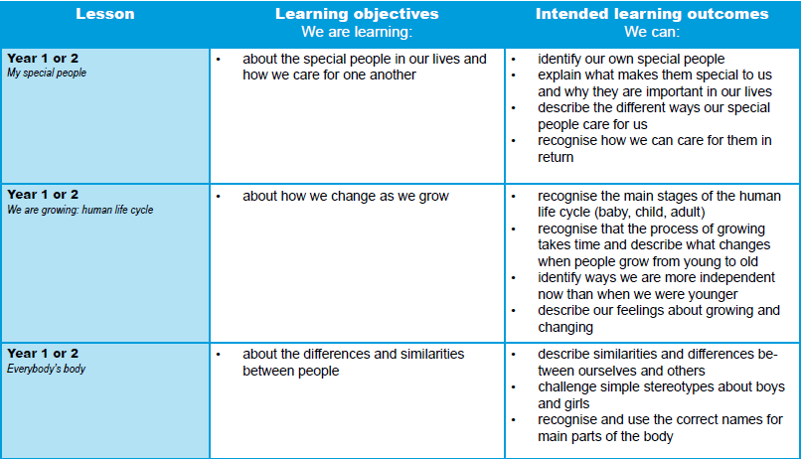

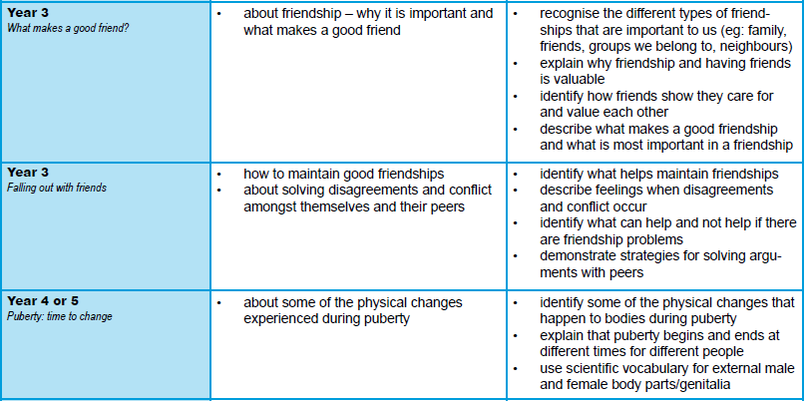

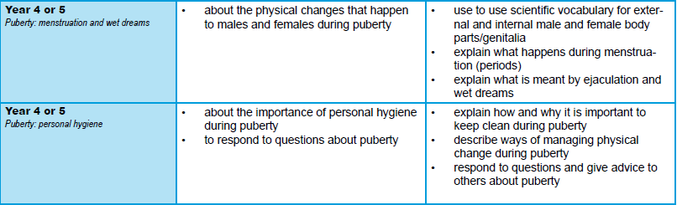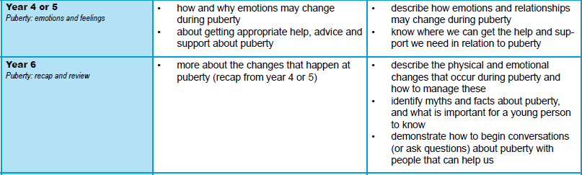

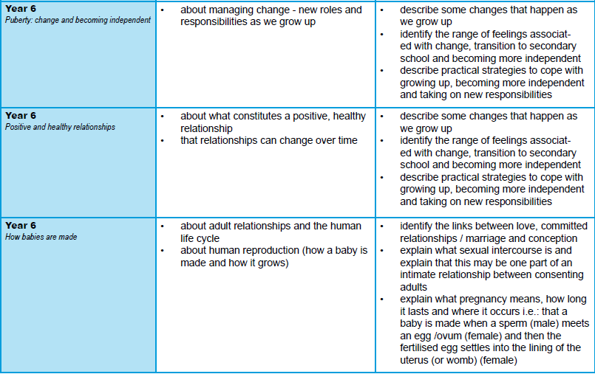

### Appendix 3: By the end of primary school pupils should know

| Topic | Pupils should know |
| --- | --- |
| Families and people who care about me | * That families are important for children growing up because they can give love, security and stability * The characteristics of healthy family life, commitment to each other, including in times of difficulty, protection and care for children and other family members, the importance of spending time together and sharing each other’s lives * That others’ families, either in school or in the wider world, sometimes look different from their family, but that they should respect those differences and know that other children’s families are also characterised by love and care * That stable, caring relationships, which may be of different types, are at the heart of happy families, and are important for children’s security as they grow up * That marriage represents a formal and legally recognised commitment of two people to each other which is intended to be lifelong * How to recognise if family relationships are making them feel unhappy or unsafe, and how to seek help or advice from others if needed |
| Caring friendships | * How important friendships are in making us feel happy and secure, and how people choose and make friends * The characteristics of friendships, including mutual respect, truthfulness, trustworthiness, loyalty, kindness, generosity, trust, sharing interests and experiences and support with problems and difficulties * That healthy friendships are positive and welcoming towards others, and do not make others feel lonely or excluded * That most friendships have ups and downs, and that these can often be worked through so that the friendship is repaired or even strengthened, and that resorting to violence is never right * How to recognise who to trust and who not to trust, how to judge when a friendship is making them feel unhappy or uncomfortable, managing conflict, how to manage these situations and how to seek help or advice from others, if needed |
| Respectful relationships | * The importance of respecting others, even when they are very different from them (for example, physically, in character, personality or backgrounds), or make different choices or have different preferences or beliefs * Practical steps they can take in a range of different contexts to improve or support respectful relationships * The conventions of courtesy and manners * The importance of self-respect and how this links to their own happiness * That in school and in wider society they can expect to be treated with respect by others, and that in turn they should show due respect to others, including those in positions of authority * About different types of bullying (including cyberbullying), the impact of bullying, responsibilities of bystanders (primarily reporting bullying to an adult) and how to get help * What a stereotype is, and how stereotypes can be unfair, negative or destructive * The importance of permission-seeking and giving in relationships with friends, peers and adults |
| Online relationships | * That people sometimes behave differently online, including by pretending to be someone they are not * That the same principles apply to online relationships as to face-to face relationships, including the importance of respect for others online including when we are anonymous * The rules and principles for keeping safe online, how to recognise risks, harmful content and contact, and how to report them * How to critically consider their online friendships and sources of information including awareness of the risks associated with people they have never met * How information and data is shared and used online |
| Being safe | * What sorts of boundaries are appropriate in friendships with peers and others (including in a digital context) * About the concept of privacy and the implications of it for both children and adults; including that it is not always right to keep secrets if they relate to being safe * That each person’s body belongs to them, and the differences between appropriate and inappropriate or unsafe physical, and other, contact * How to respond safely and appropriately to adults they may encounter (in all contexts, including online) whom they do not know * How to recognise and report feelings of being unsafe or feeling bad about any adult * How to ask for advice or help for themselves or others, and to keep trying until they are heard * How to report concerns or abuse, and the vocabulary and confidence needed to do so * Where to get advice e.g. family, school and/or other sources |

### Appendix 4: Parent form: withdrawal from sex education within RSE

| To be completed by parents | | | |
| --- | --- | --- | --- |
| Name of child |  | Class |  |
| Name of parent |  | Date |  |
| Reason for withdrawing from sex education within relationships and sex education | | | |
|  | | | |
| Any other information you would like the school to consider | | | |
|  | | | |
| Parent signature |  | | |

| To be completed by the school | |
| --- | --- |
| Agreed actions from discussion with parents |  |
|  |  |

### Appendix 5: Sex Education covered within the Science National Curriculum

|  |  |
| --- | --- |
| Year 1 | identify, name, draw and label the basic parts of the human body and say which part of the body is associated with each sense. |
| Year 2 | notice that animals, including humans, have offspring which grow into adults. |
| Year 5 | describe the changes as humans develop to old age.  (Pupils should draw a timeline to indicate stages in the growth and development of humans. They should learn about the changes experienced in puberty.  Pupils could work scientifically by researching the gestation periods of other animals and comparing them with humans; by finding out and recording the length and mass of a baby as it grows.) |